**Image Model Training**

There are a number of advantages of using the Azure AML platform to create computer vision models. These include:

1. An Enterprise grade platform service that facilitates the following capabilities when training and deploying CV models:
   1. A single platform to label, train and deploy models
   2. Scalability the ability to execute the code for the model training on one compute while the real training of the model happens on another compute that is completely scalable to align with the number of images and modeling tasks.
   3. Using the hyperdrive functionality of AutoML for images, it is possible to train hundreds of models using different algorithms and hyperparameters and then automatically have AML determine the best (champion) model automatically. This alone with the forementioned capabilities saves time and helps scale the overall model training/deployment process.

**Creating a Storage Account and loading the image data:**

1. Create a Storage account with Blob store container. If you are unsure how to create the storage account and upload the images use the following details and links to learn how.
2. **Please note:** As you create the storage account make sure you record the ***Storage Account Name, Blob Container Name and Access Key*** as these will be needed later on when we create a Datastore in AML.
   1. **Storage Account overview (Concepts)**: [Explore Azure Storage services - Learn | Microsoft Docs](https://docs.microsoft.com/en-us/learn/modules/azure-storage-fundamentals/)

## Storage Account an Blob Store creation:

To access Azure Storage, you'll need an Azure subscription. If you don't already have a subscription, create a [free account](https://azure.microsoft.com/free/?WT.mc_id=A261C142F) before you begin.

All access to Azure Storage takes place through a storage account. For this quickstart, create a storage account using the [Azure portal](https://portal.azure.com/), Azure PowerShell, or Azure CLI. For help creating a storage account, see [Create a storage account](https://docs.microsoft.com/en-us/azure/storage/common/storage-account-create).

**Name your storage account:** **<**your unique storage account name**>**

Record this name as it will be needed later.

## Create a container

To create a container in the Azure portal, follow these steps:

1. Navigate to your new storage account in the Azure portal.
2. In the left menu for the storage account, scroll to the **Data storage** section, then select **Containers**.
3. Select the **+ Container** button.
4. Type a name for your new container. **Name your container**: **<**your container name**>** The container name must be lowercase, must start with a letter or number, and can include only letters, numbers, and the dash (-) character. For more information about container and blob names, see [Naming and referencing containers, blobs, and metadata](https://docs.microsoft.com/en-us/rest/api/storageservices/naming-and-referencing-containers--blobs--and-metadata).
5. Set the level of public access to the container. The default level is **Private (no anonymous access)**.
6. Select **Create** to create the container.

[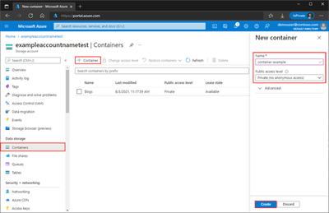](https://docs.microsoft.com/en-us/azure/storage/blobs/media/storage-quickstart-blobs-portal/create-container-lrg.png#lightbox)

1. Once the container is created go to the Access keys area under the Security + networking portion of the panel and select the icon

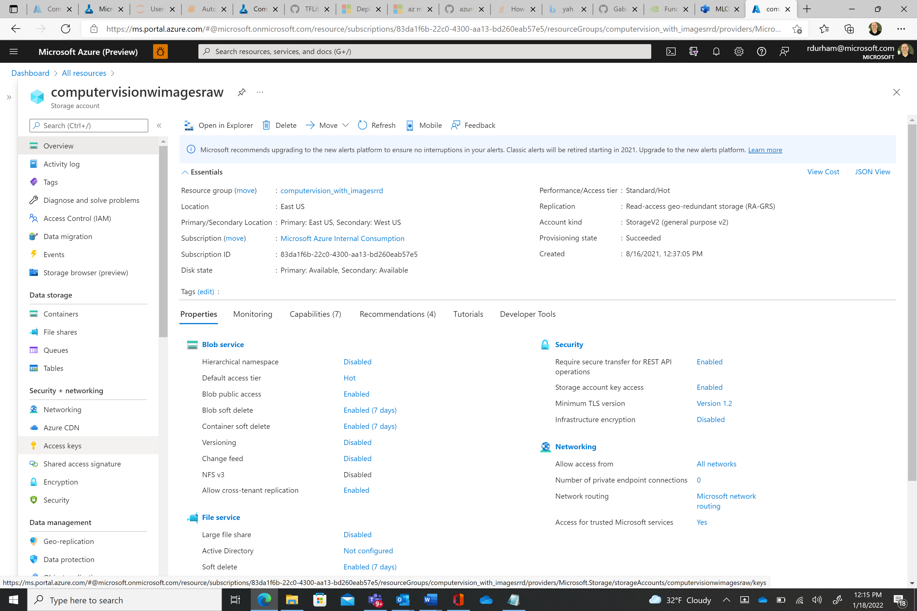



This will bring up the following screen. Click on the “Show keys” icon (shown below as Hide keys) and copy the key to the clipboard and then record it in notepad. This key will be needed later.

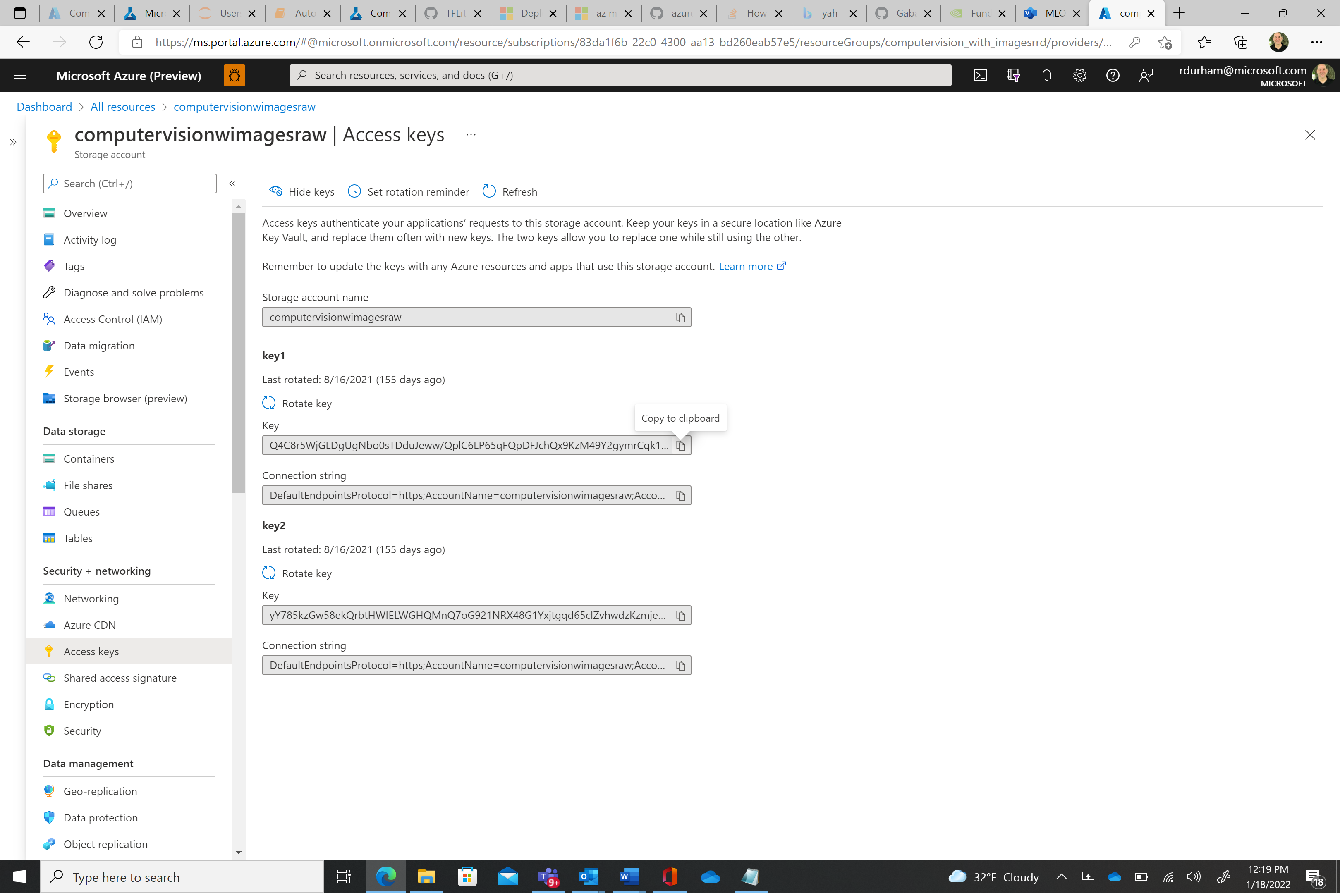

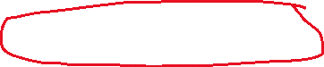

Upload the provided image data. This can be found by downloading and uncompressing the zip file found in **GTC\soda_data.zip.** The image data from this zip file can be found in the **soda_data\train_img\** directoryand uploaded into the Storage account container named **soda-raw**. This should be 243 images. These images are numbered **0.jpg – 244.jpg**. Please note that at a minimum you will need at least 50 images to train an AutoML for Images model.

For a reference on how to do this review the following link:

[Quickstart: Upload, download, and list blobs - Azure portal - Azure Storage | Microsoft Docs](https://docs.microsoft.com/en-us/azure/storage/blobs/storage-quickstart-blobs-portal)

# **Create workspace resources you need to get started with Azure Machine Learning**

## Create the workspace

If you already have a workspace, skip this section and continue to [Create a compute instance](https://docs.microsoft.com/en-us/azure/machine-learning/quickstart-create-resources#instance).

If you don't yet have a workspace, create one now:

1. Sign in to the [Azure portal](https://portal.azure.com/) by using the credentials for your Azure subscription.
2. In the upper-left corner of the Azure portal, select the three bars, then **+ Create a resource**.

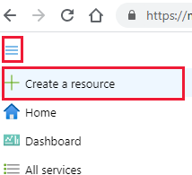

1. Use the search bar to find **Machine Learning**.
2. Select **Machine Learning**.
3. In the **Machine Learning** pane, select **Create** to begin.
4. 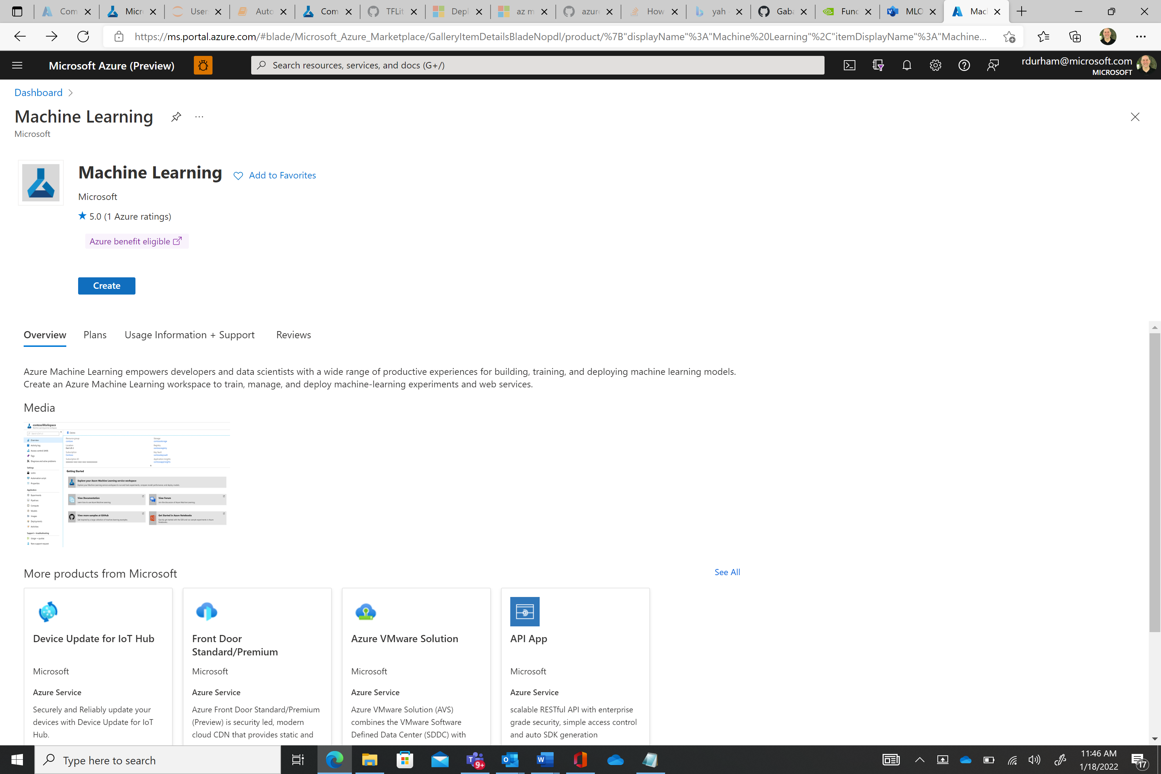



1. Provide the following information to configure your new workspace: **Note you may need to create a new resource group, workspacename, storage account, key vault, application insights and container registry for the workspace**. An example label might be using computervision + <your initials> as the textbox entry.

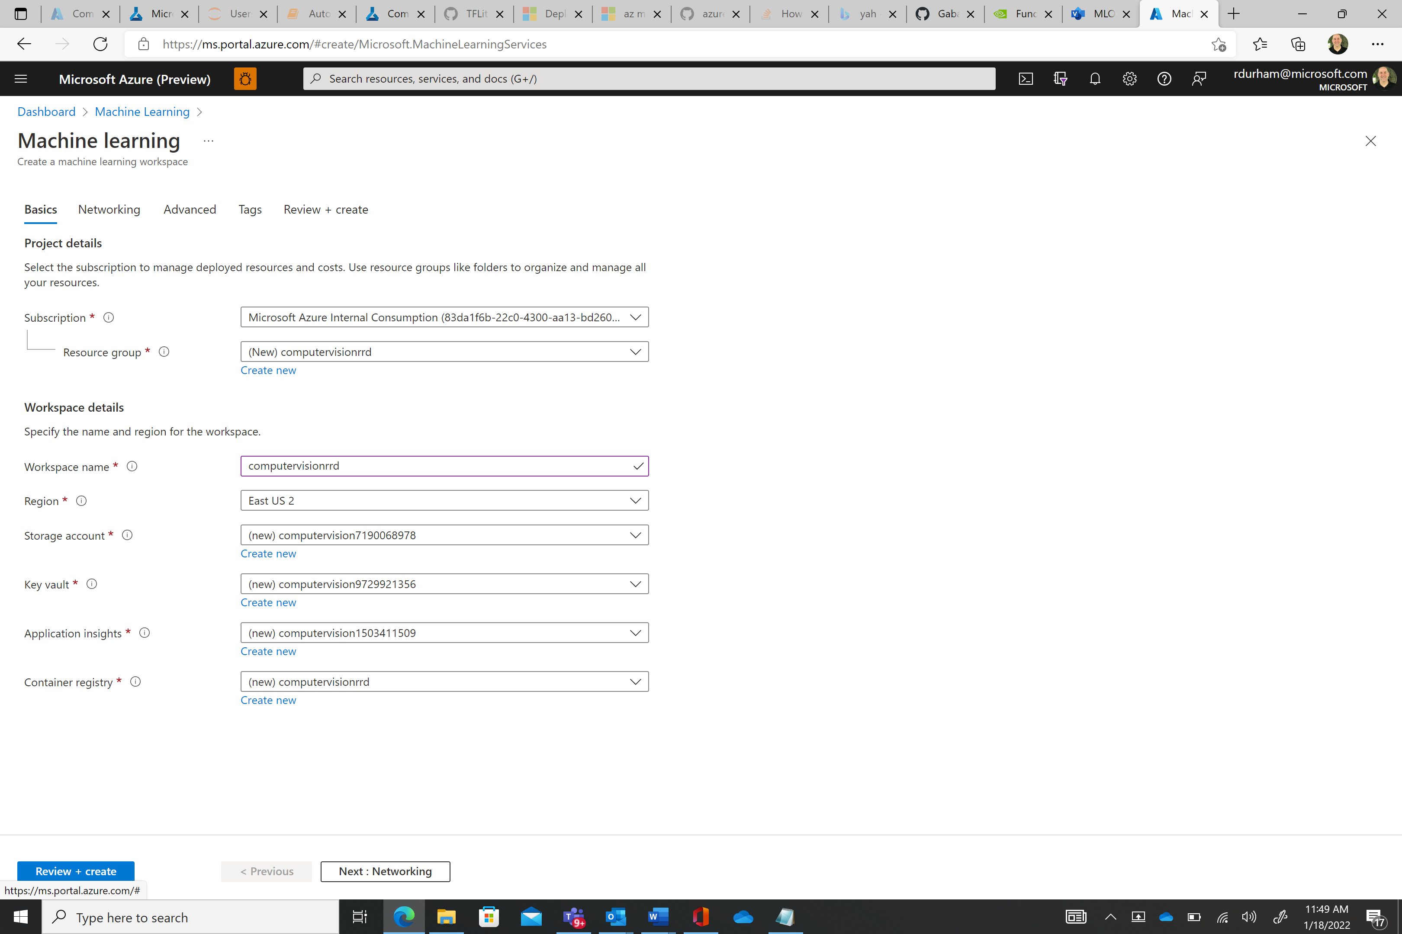

1. Select **Review and create** to create the workspace.

**Warning**

It can take several minutes to create your workspace in the cloud.

When the process is finished, a deployment success message appears.

1. To view the new workspace go the Azure Portal and enter “**Machine Learning**” in the search bar:

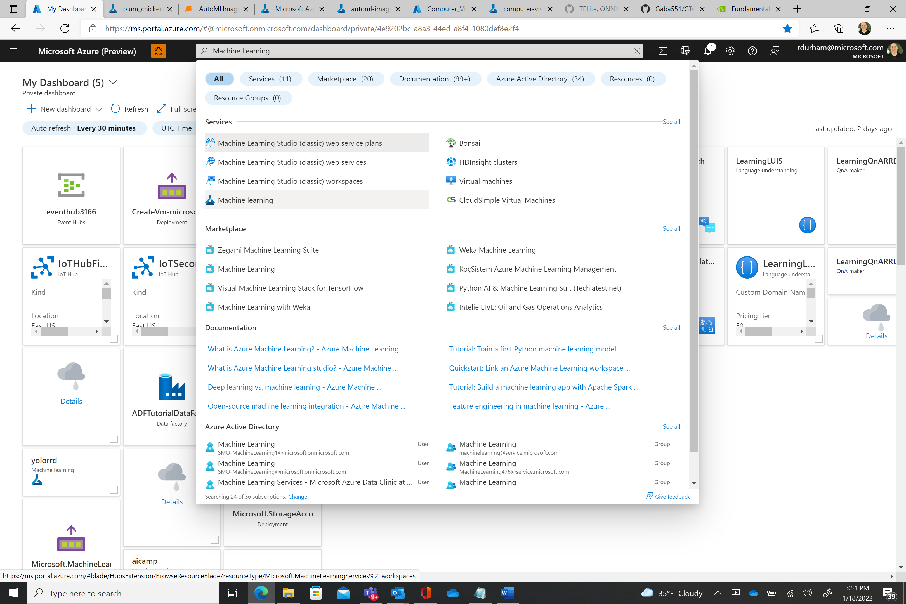



1. Download the **config.json** file and store it locally for use later in this tutorial (see the image below for download location)

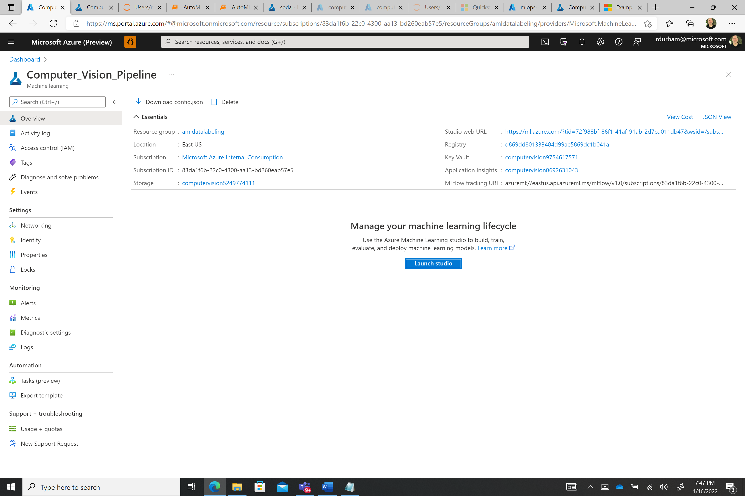



1. From the portal view of your workspace, select **Launch studio** to go to the Azure Machine Learning studio.



## Create compute instance

You could install Azure Machine Learning on your own computer. But in this quickstart, you'll create an online compute resource that has a development environment already installed and ready to go. You'll use this online machine, a compute instance, for your development environment to write and run code in Python scripts and Jupyter notebooks.

Create a compute instance to use this development environment for the rest of the tutorials and quickstarts.

1. If you didn't select **Go to workspace** in the previous section, sign in to [Azure Machine Learning studio](https://ml.azure.com/) now, and select your workspace.
2. You can do this by typing in “**Azure Machine Learning**” on the search bar and choosing the Machine Learning icon
3. 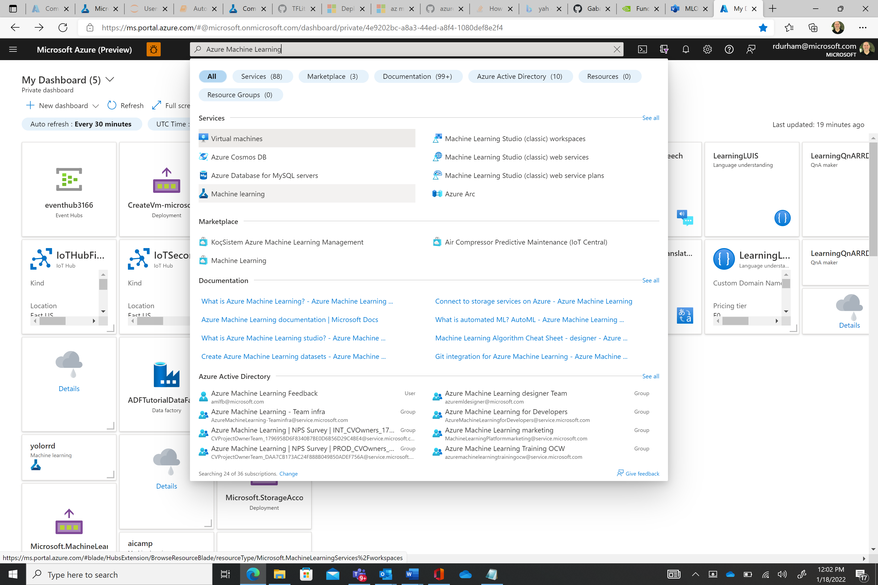



1. This will give you a list of AML workspaces to choose from:
2. 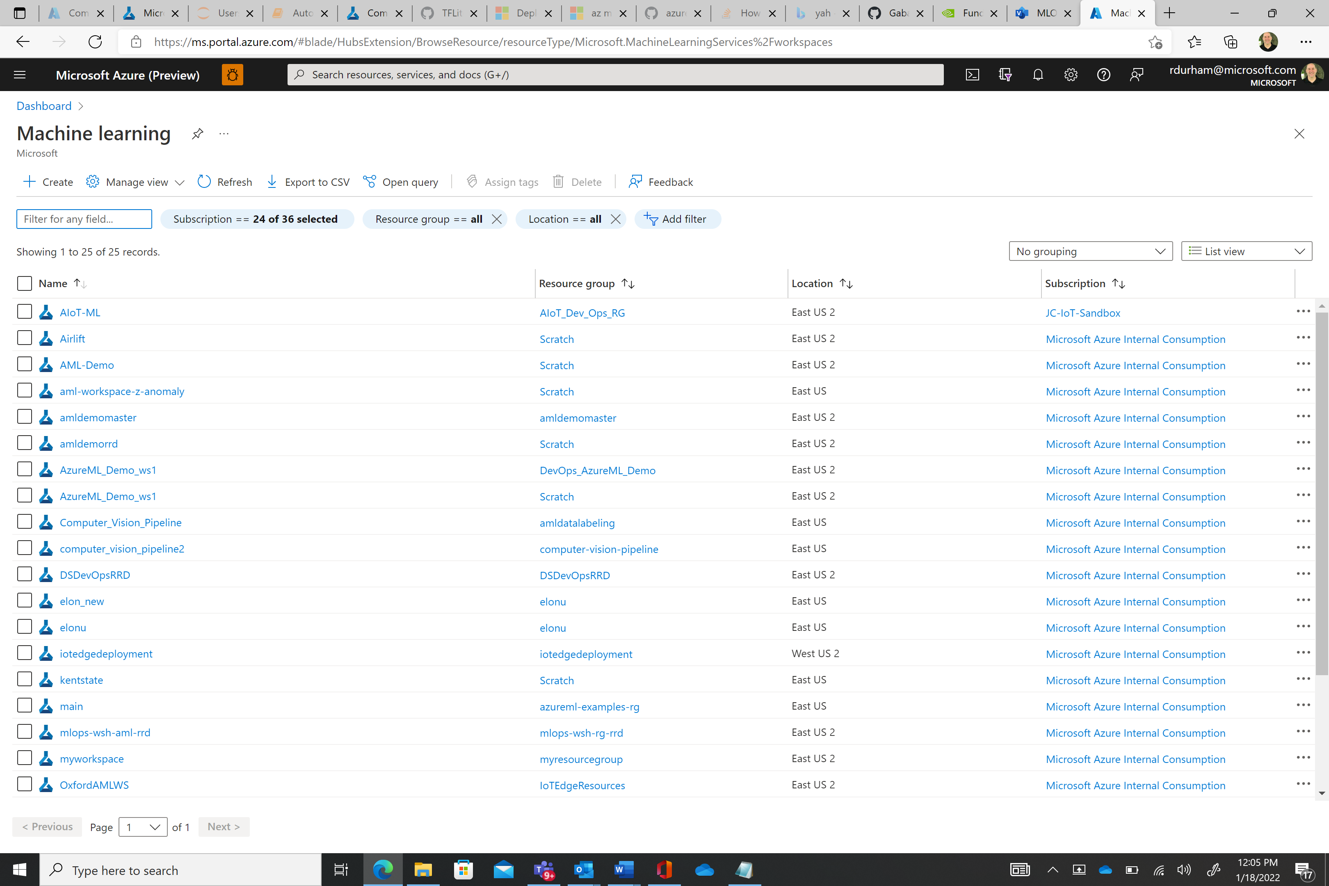
3. Once you are in your AML workspace On the left side, select **Compute**.
4. 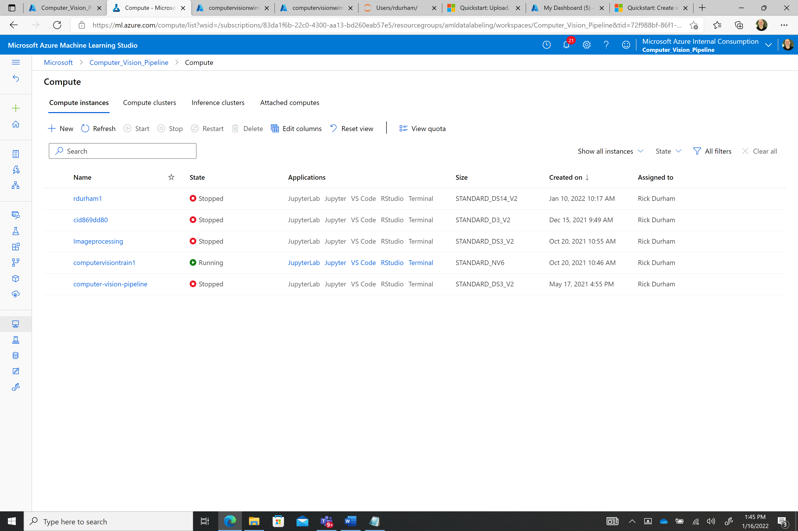



1. Select **+New** to create a new compute instance.
2. Supply a name like **Imageprocessing**. **Keep all the defaults on the first page**.
3. Select **Create**.

In about two minutes, you'll see the **State** of the compute instance change from Creating to Running. It's now ready to go. Now that we have an AML workspace created and a compute instance we are ready to setup our AML Data Store and AML Dataset. This Data Store and Data Set will point back to the image data we uploaded in previous steps.

**Create a new datastore in a few steps with the Azure Machine Learning studio.**

**Important**

1. Sign in to [Azure Machine Learning studio](https://ml.azure.com/).
2. Select **Datastores** on the left pane under **Manage**.
3. 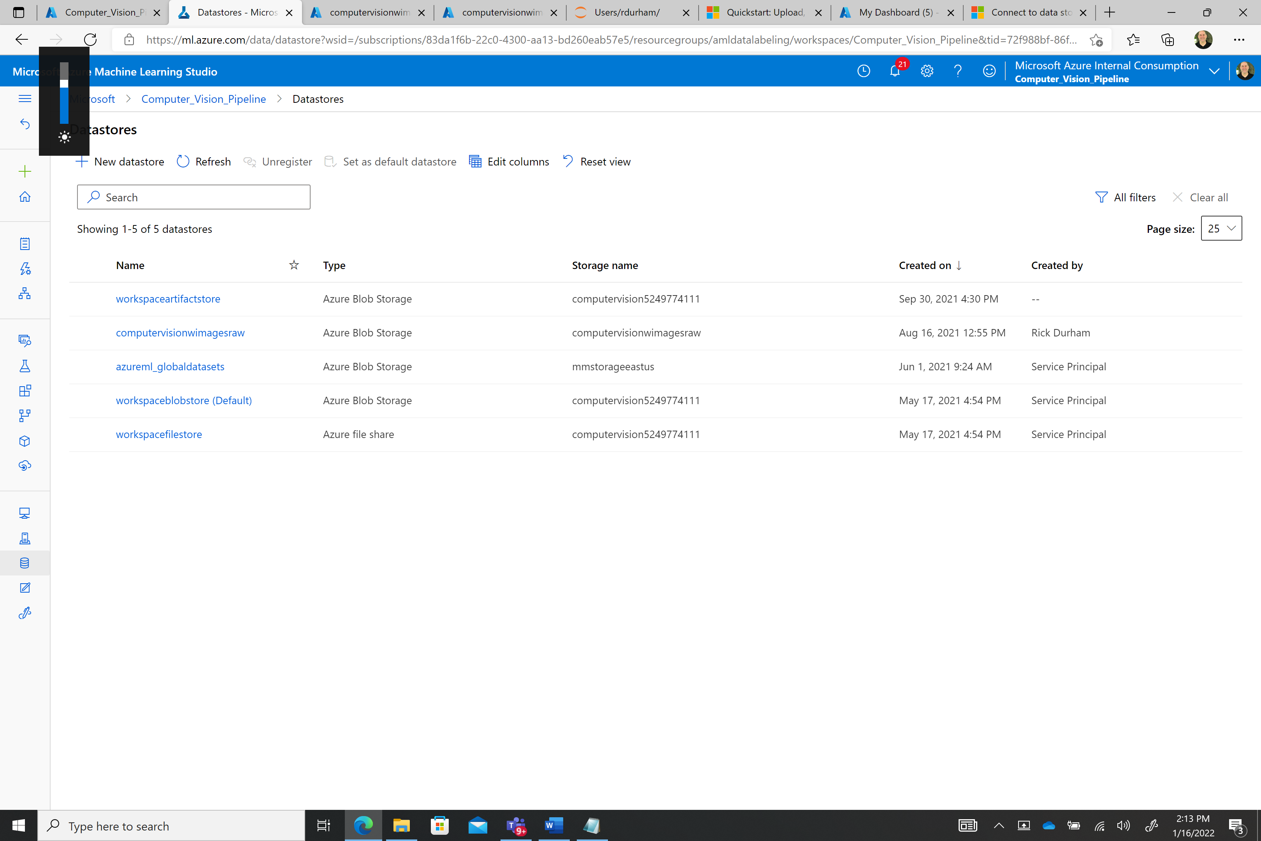



1. Select **+ New datastore**.
2. Complete the form to create and register a new datastore. The form intelligently updates itself based on your selections for Azure storage type and authentication type. Name the Datastore using a name similar to the one shown below. You will recall we recorded the other form entries as ***Storage Account Name, Blob Container Name and Access Key at the beginning of this workshop.*** *You will use them to verify the correct entries for the Storage Account Name, Blob Container Name dropdowns****. You will enter the Access key into the text box.***
3. See the [storage access and permissions section](https://docs.microsoft.com/en-us/azure/machine-learning/how-to-connect-data-ui#access-validation) to understand where to find the authentication credentials you need to populate this form.

The following example demonstrates what the form looks like when you create an **Azure blob datastore**:

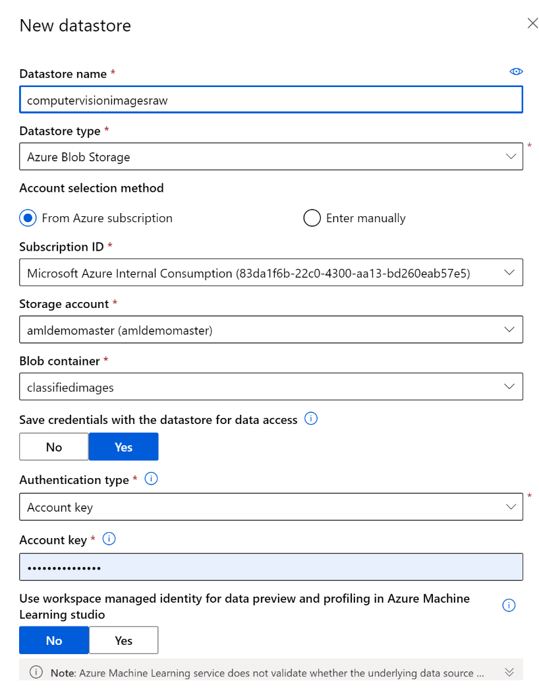

**Create a Labeled Dataset using the Azure Machine Learning Data Labeling Tools**

Here you will use Azure ML to create a dataset of labeled images using images collected on the edge, retrieved from your attached datastore.

* Navigate to your Azure Machine Learning workspace and click *Data Labeling*.

[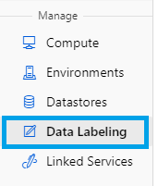](https://github.com/rutzsco/computer-vision-accelerator/blob/main/model_training/doc_img/15.png?raw=true)

* From the top menu, click *+ Add project*.

[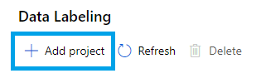](https://github.com/rutzsco/computer-vision-accelerator/blob/main/model_training/doc_img/16.png?raw=true)

* Under the *Project details* section, give your project a name that is specific to the particular detection task at hand and select *Object Identification (Bounding Box)* from the menu below, then click *Next*.

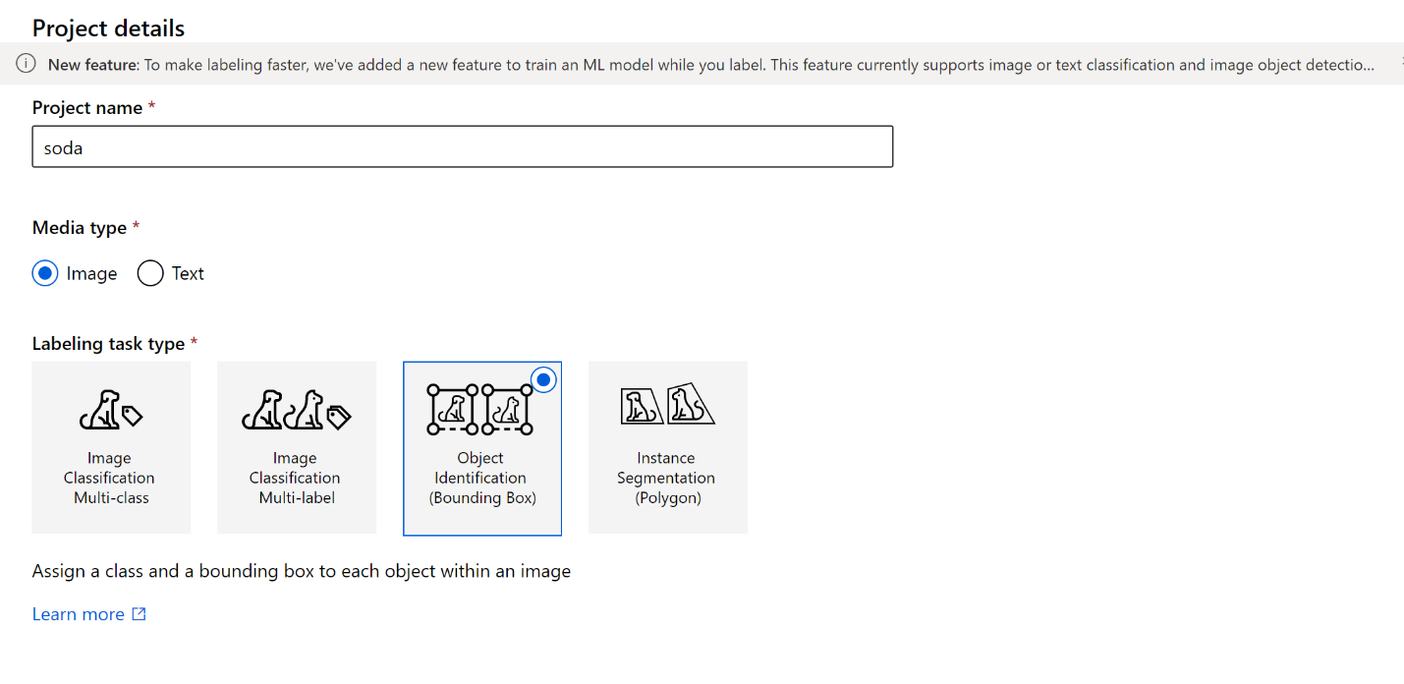

When prompted to “select or create a dataset choose”  ***+ Create dataset* and select the *From datastore* option**.

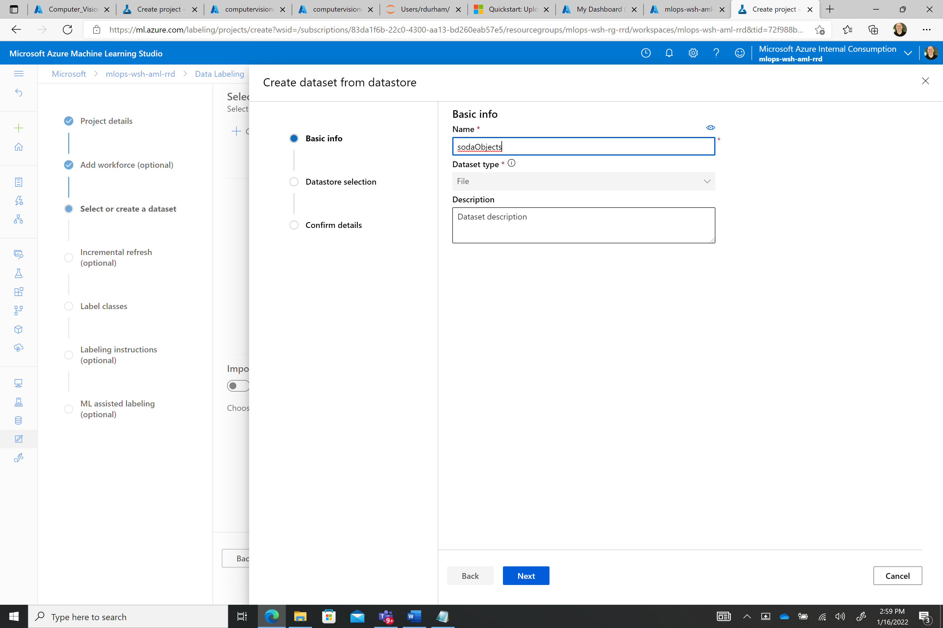

* Give your new **dataset** the unique name e.g. **sodaObjects** that reflects the images captured in support of the detection task and click *Next*.
* Under datastore selection choose the **datastore** name thatyou added previously which contains images captured. Here, you can also provide a wildcarded path if you wish to pull only images from specified partitions. If you wish to pull all images from the container, enter / as the path and click *Next*. Confirm details about your new dataset and click *Create*.

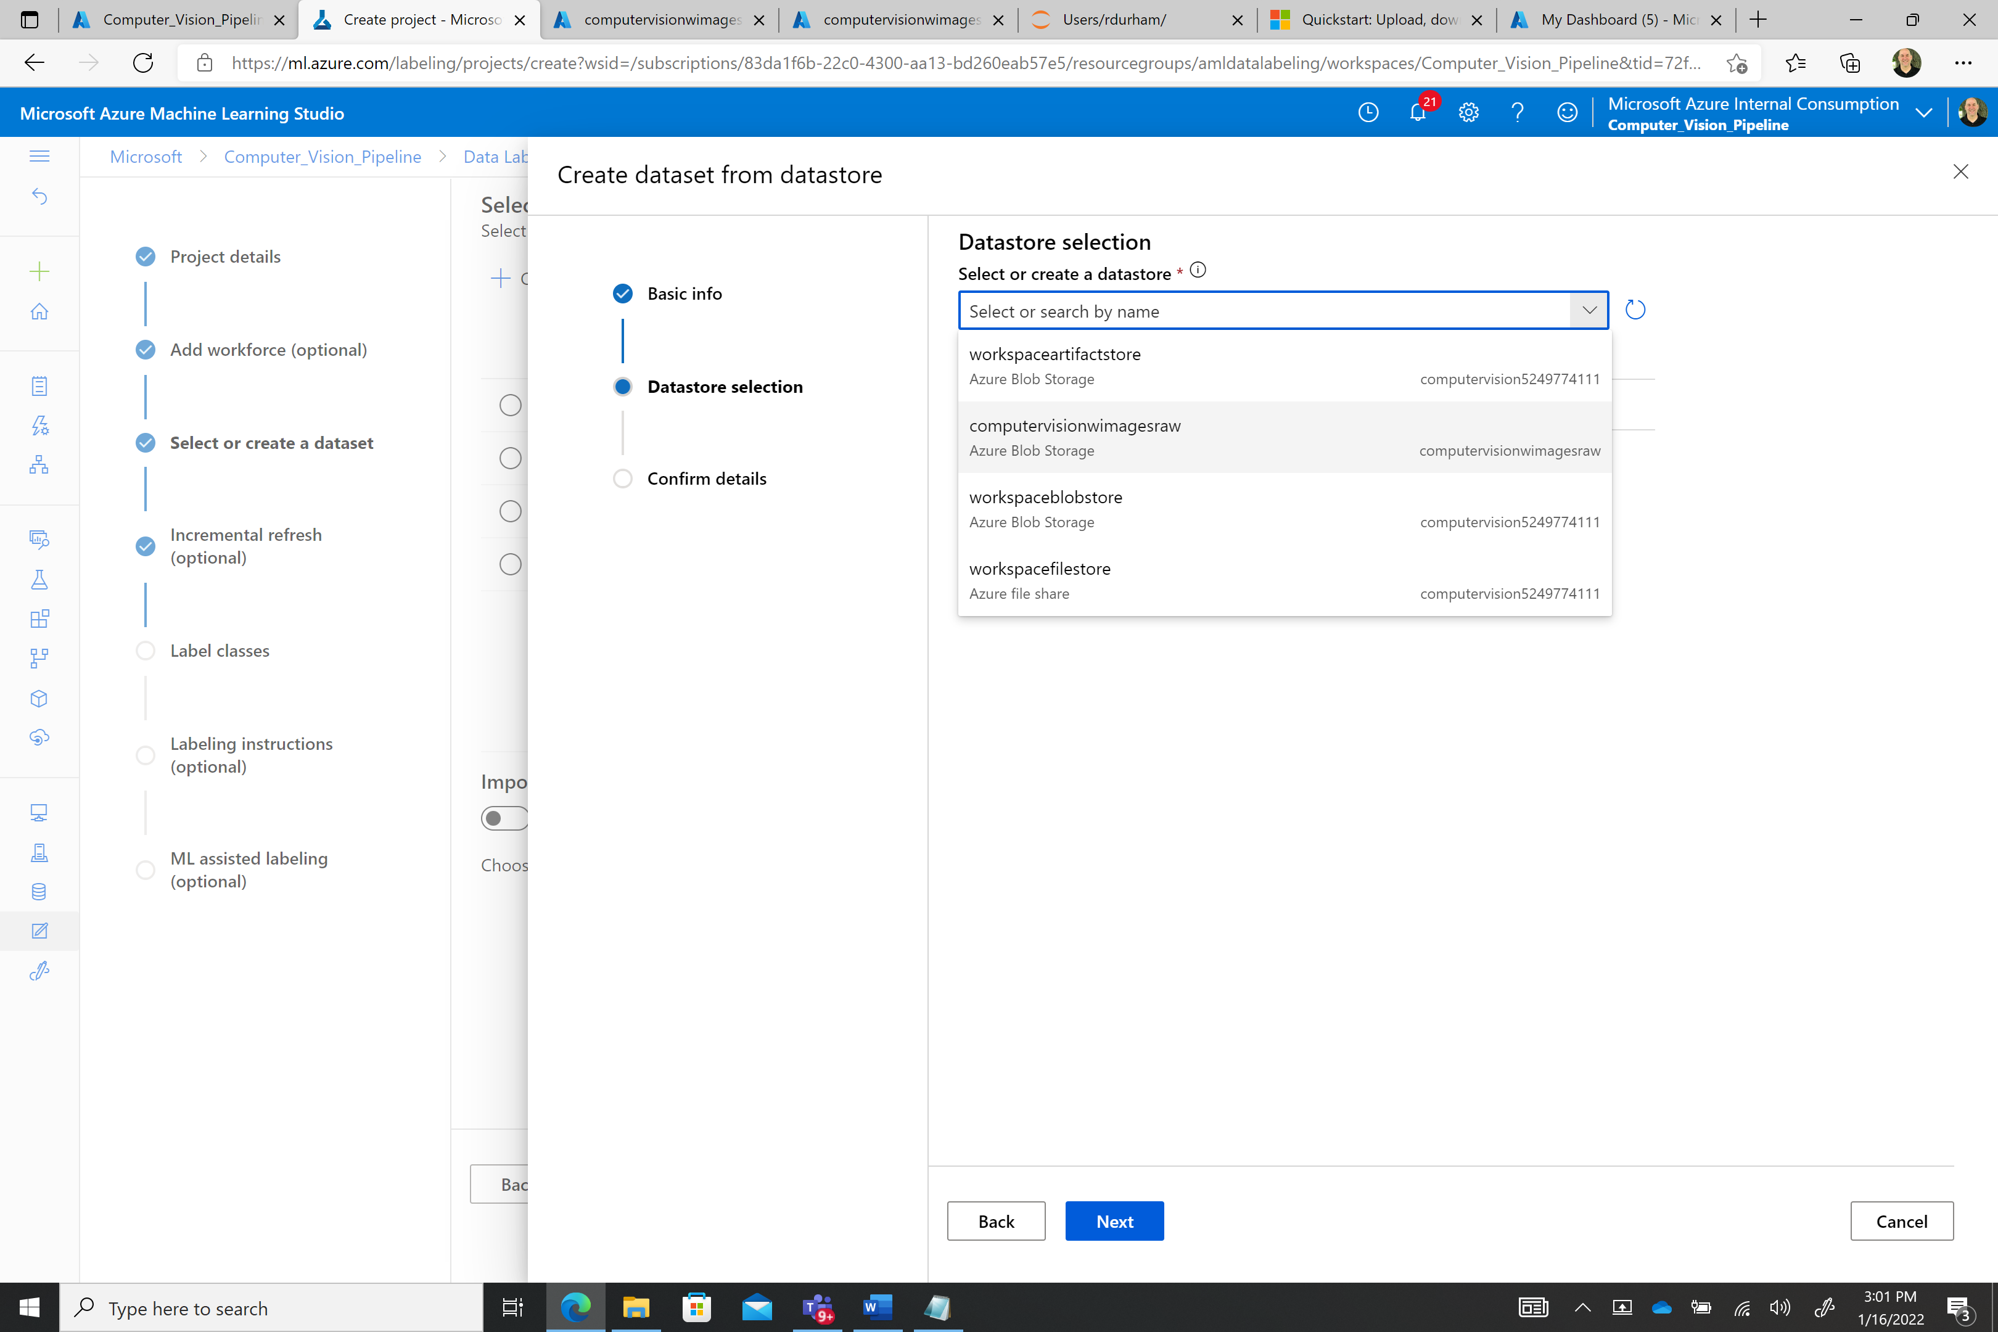



You will be prompted to Enable incremental refresh at regular intervals. This will automatically add newly captured images to your data labeling project.



[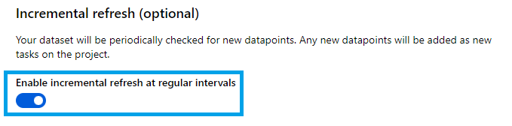](https://github.com/rutzsco/computer-vision-accelerator/blob/main/model_training/doc_img/21.png?raw=true)



On the next panel, add label classes for all objects or defects you wish to detect - include positive and negative classes here.

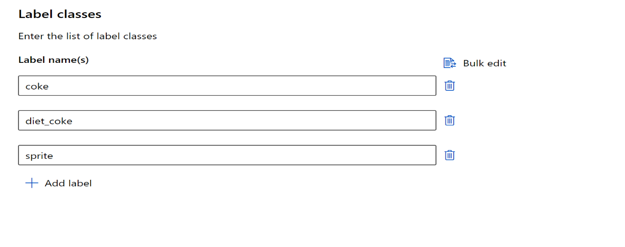

You can optionally use ML-assisted labeling which will accelerate your data labeling process, particularly as more data is captured. This option is strongly recommended.

[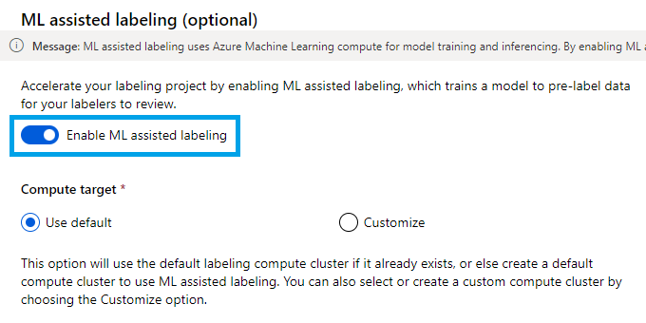](https://github.com/rutzsco/computer-vision-accelerator/blob/main/model_training/doc_img/23.png?raw=true)

* After providing all requested information click *Create project* and wait for the project to initialize.
* Click your newly created project and then select the ***Label*** *data* button. This will open a labeling utility which will allow you to draw bounding boxes and tag objects/defects present in your images. There are multiple keyboard shortcuts available which can be reviewed under the *Shortcut Keys* panel. As you label images hit the submit button and this will save the labelled image.

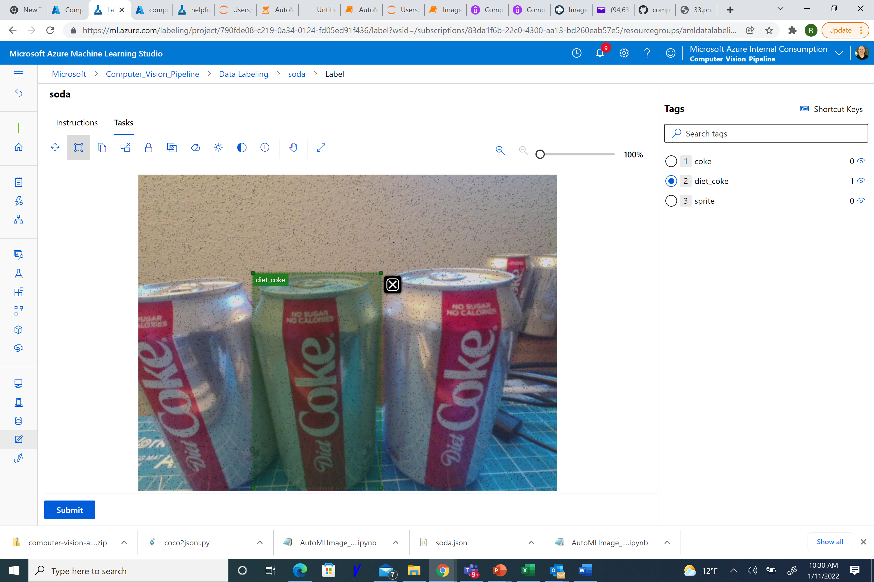

* The next step after labeling all of your images is to export an annotation file. After labeling a large number of images, navigate to the data labeling project homepage and click *Export* then select *Azure ML Dataset*. This will export your image dataset as an AutoML-compatible Azure ML dataset named according to the format 'NAME_DATE_TIME'.

This is done as follows:

1. Select Export from the Data Labeling Menu
2. Choose **Azure ML dataset**

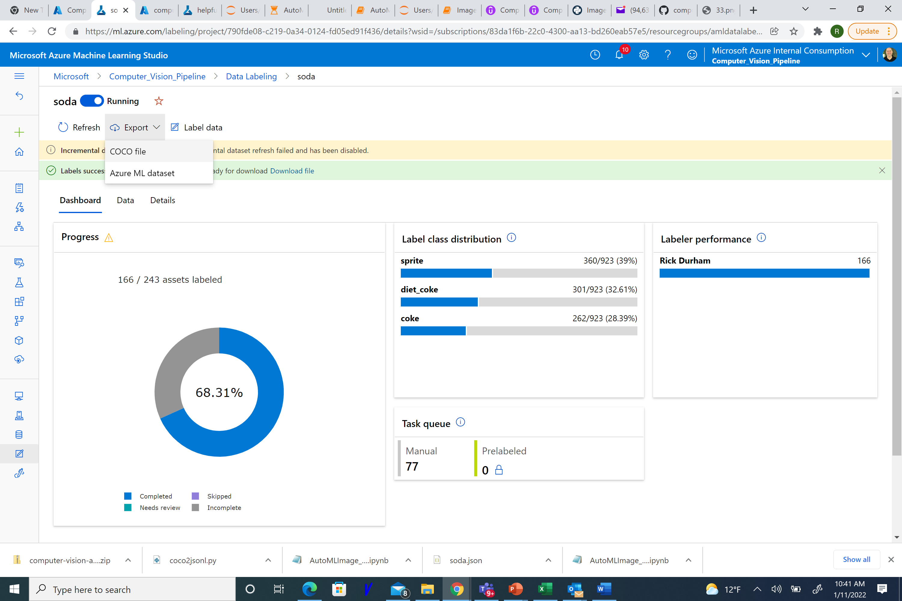



Click on the **View dataset** link

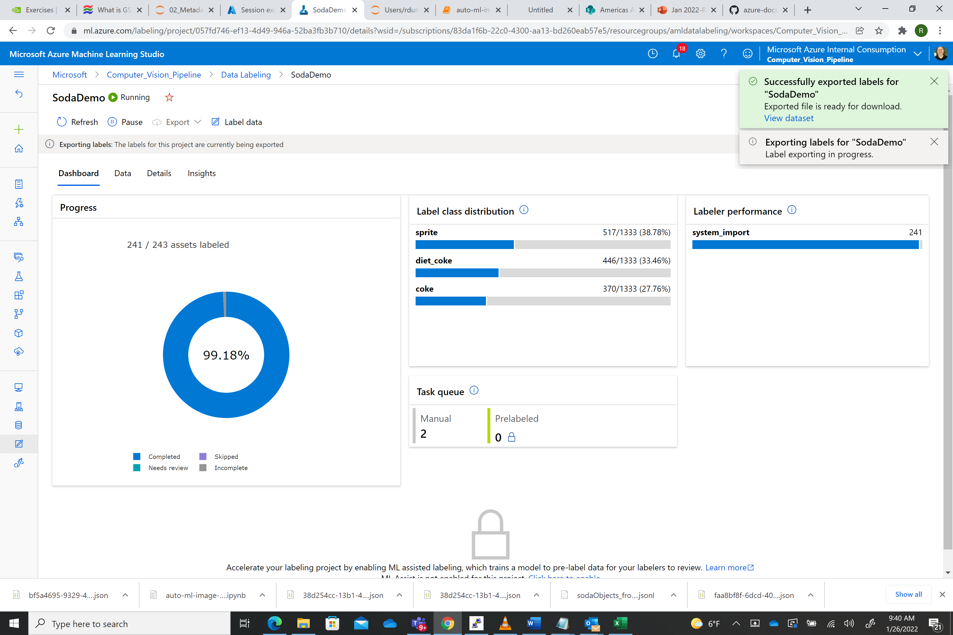



This will open a view to the newly created dataset. Copy the name of the AML ML dataset in this case it is named “ **SodaDemo_20220126_144158”**

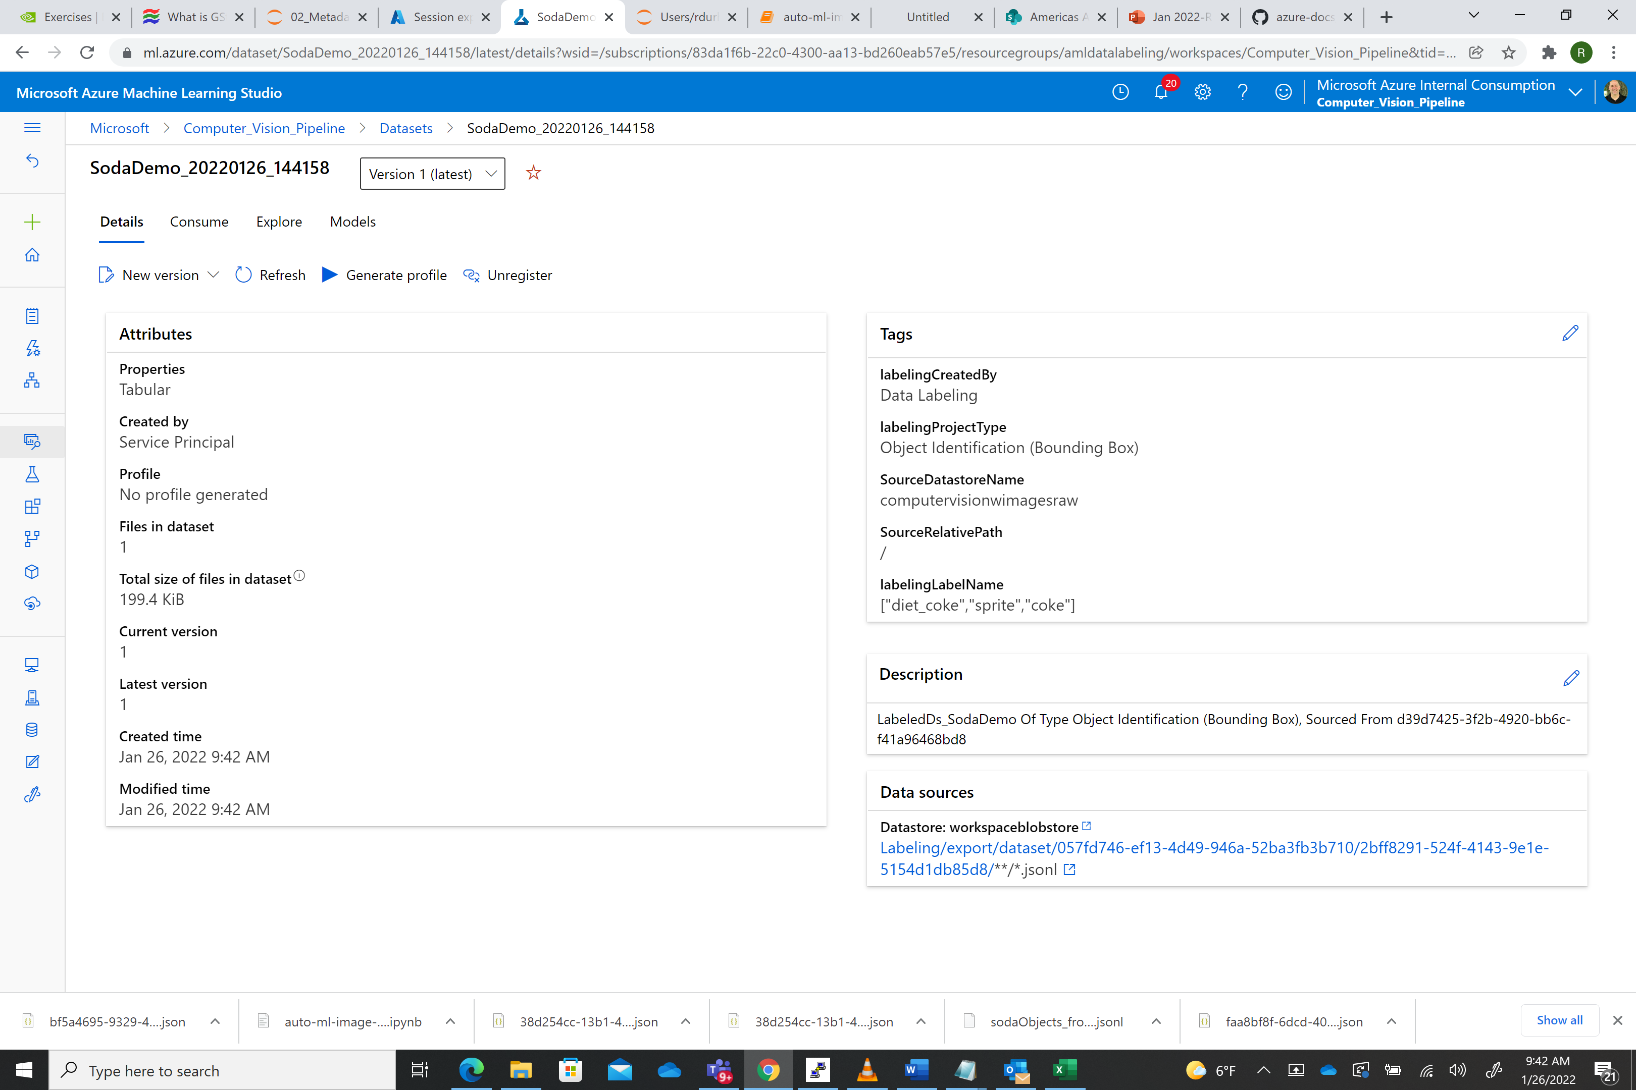



Open the AML Workspace you created earlier:

1. **Go to workspace** in the previous section, sign in to [Azure Machine Learning studio](https://ml.azure.com/) now, and select your workspace. Select the compute icon and click on the **Jupyter** link:

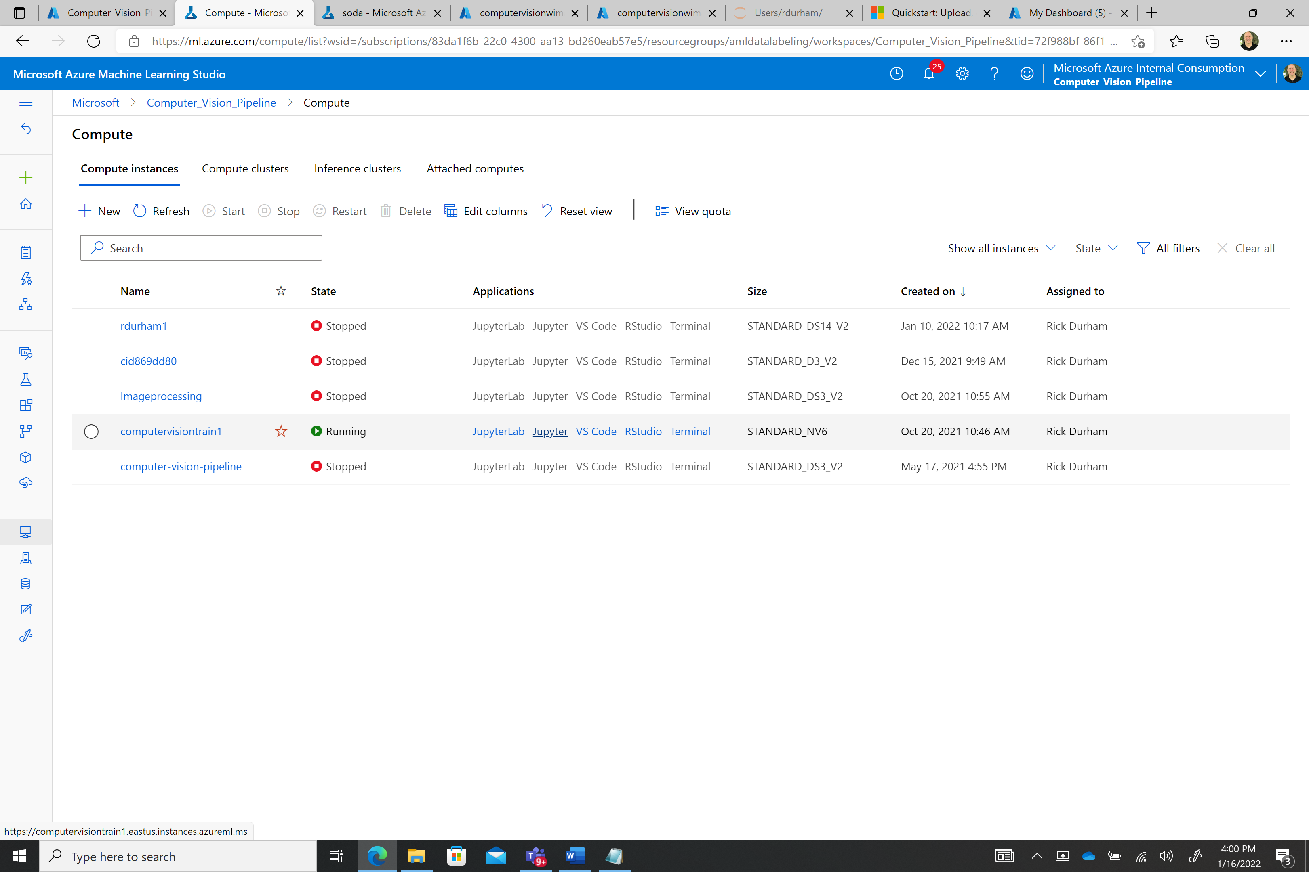



Click on the users directory and select the your user name directory e.g.:

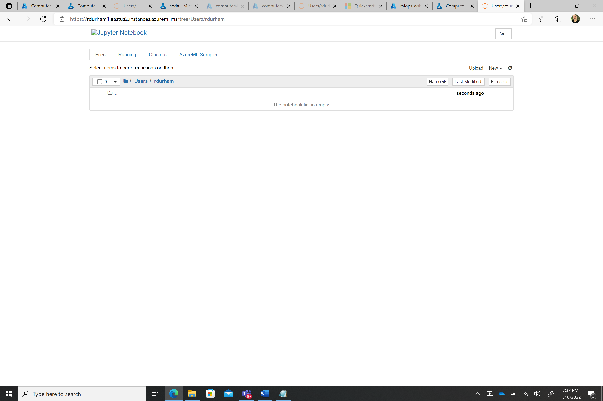

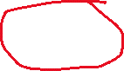

Use the upload buttom (top right) to upload the **auto-ml-image-object-detection_latest-V2.ipynb** Jupyter notebook from the local drive where you stored in the **GTC\ directory**

Upload the **config.json** Using the new menu dropdown create a new folder called **sodaObjects**. Once you finished your environment should look like the following:

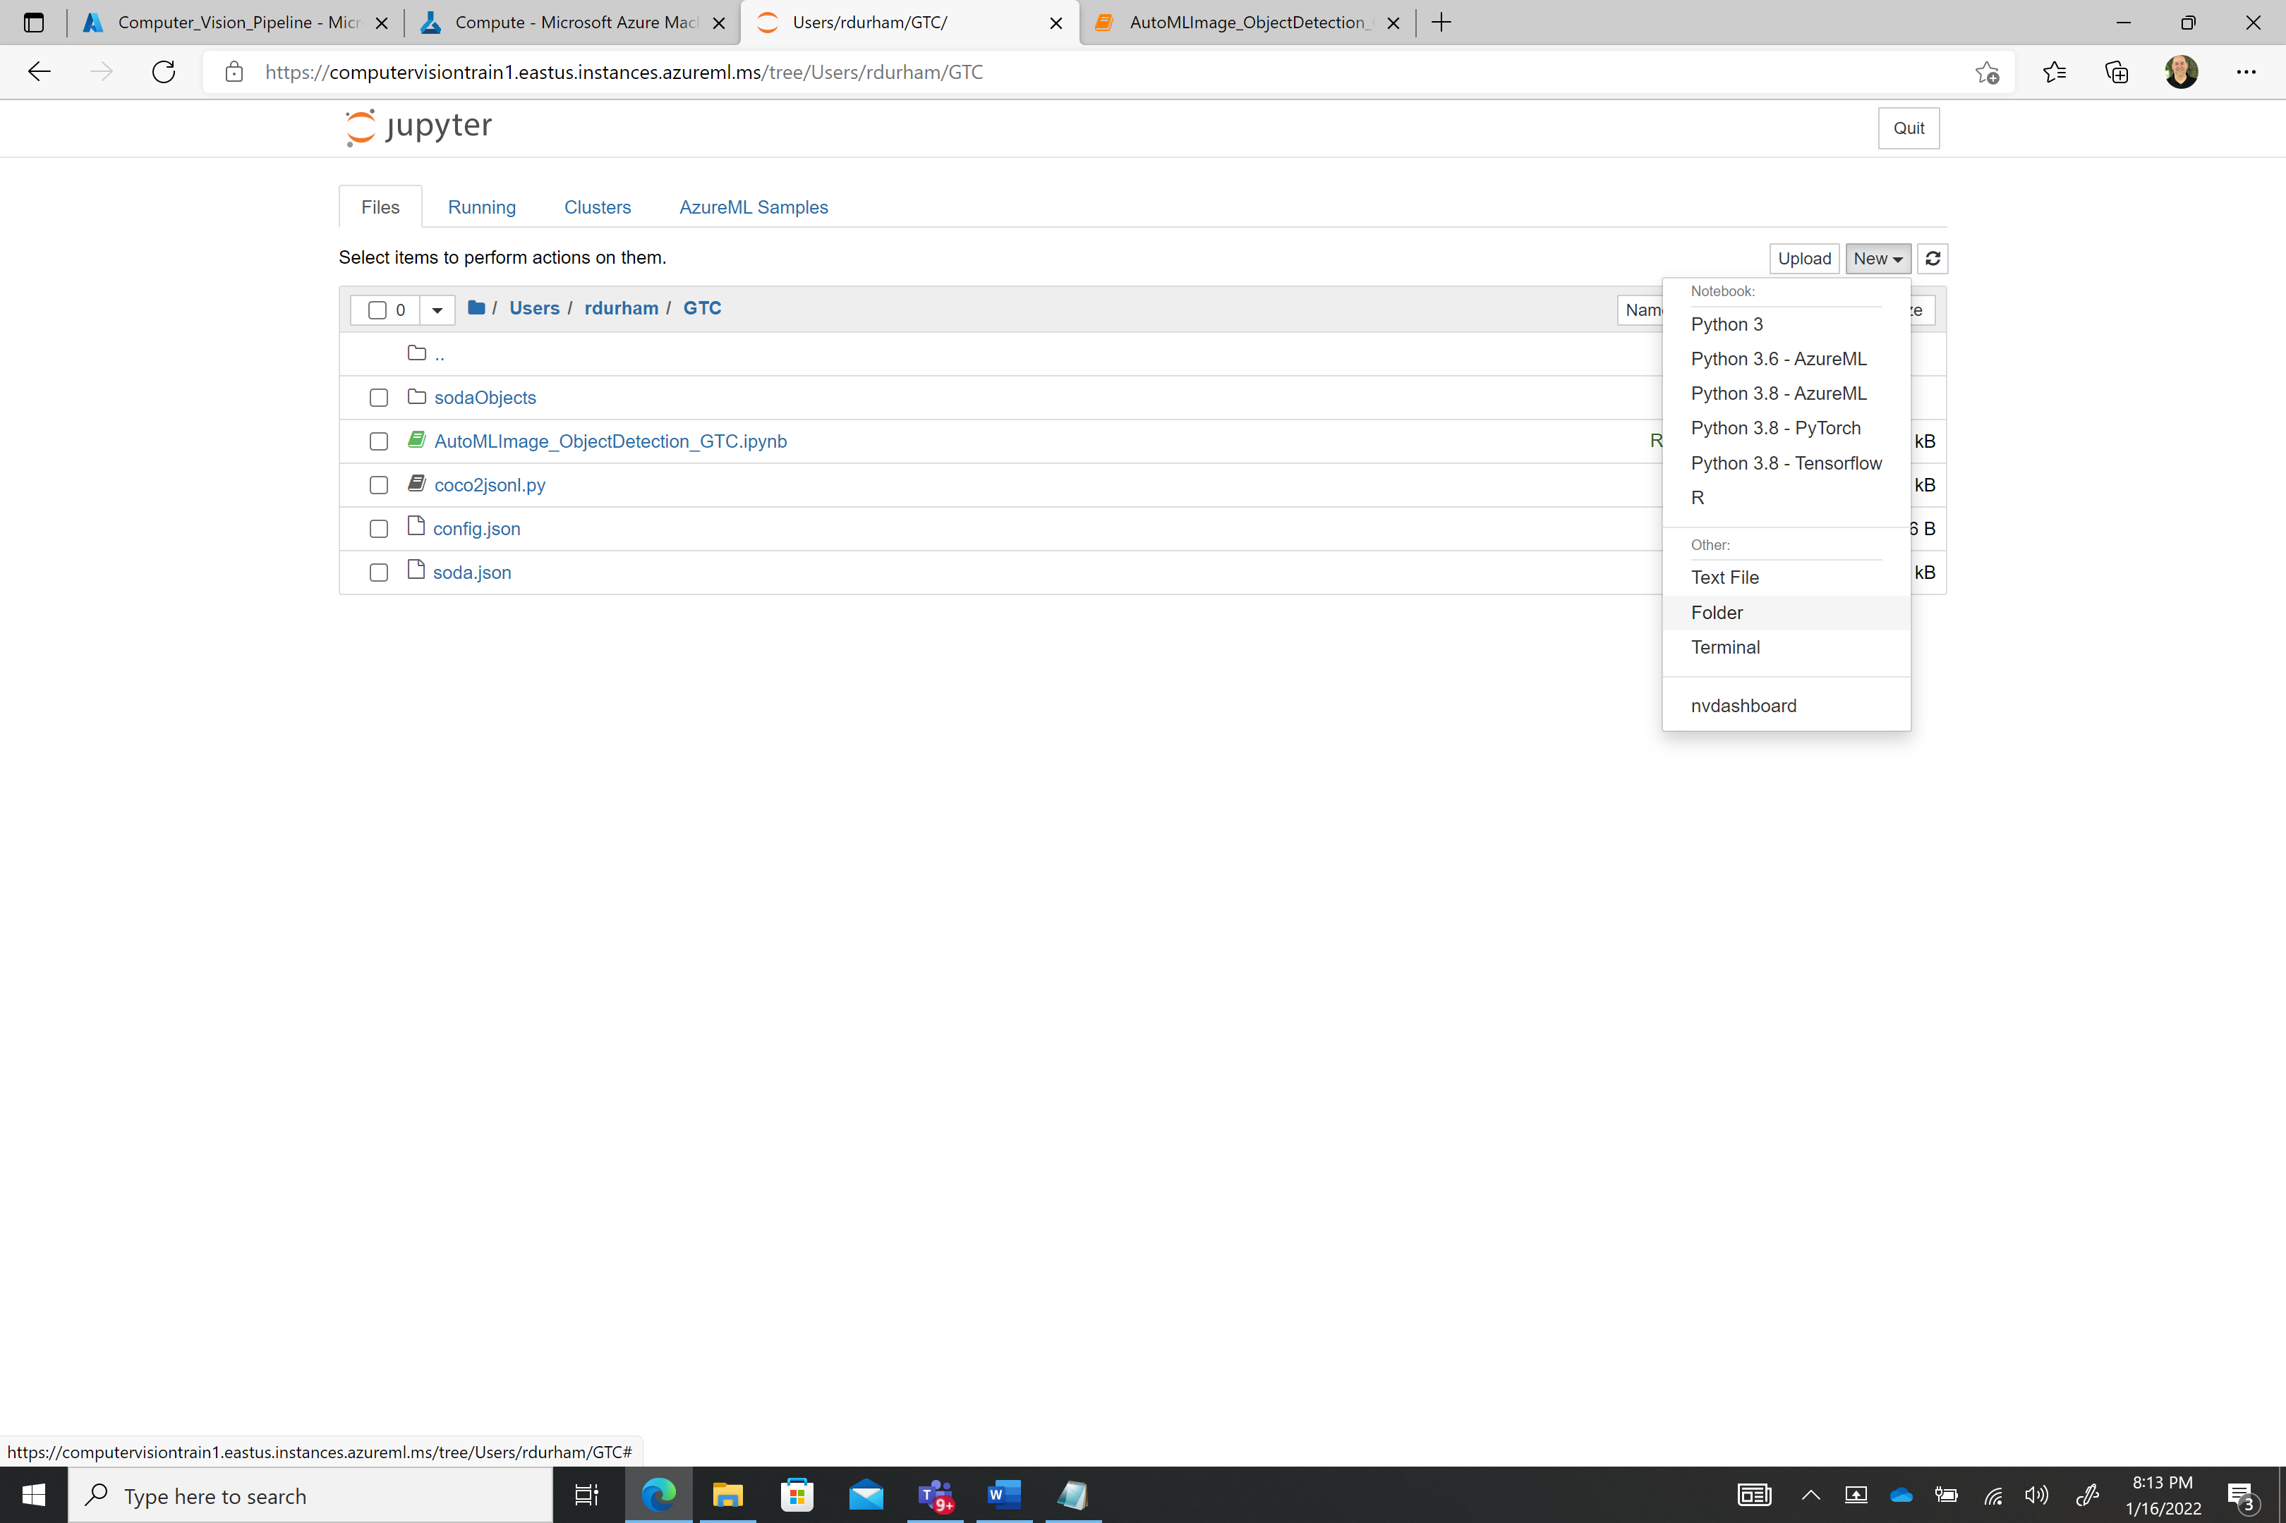



Upload the file **test_image1.jpg** into the same folder where the notebook resides.

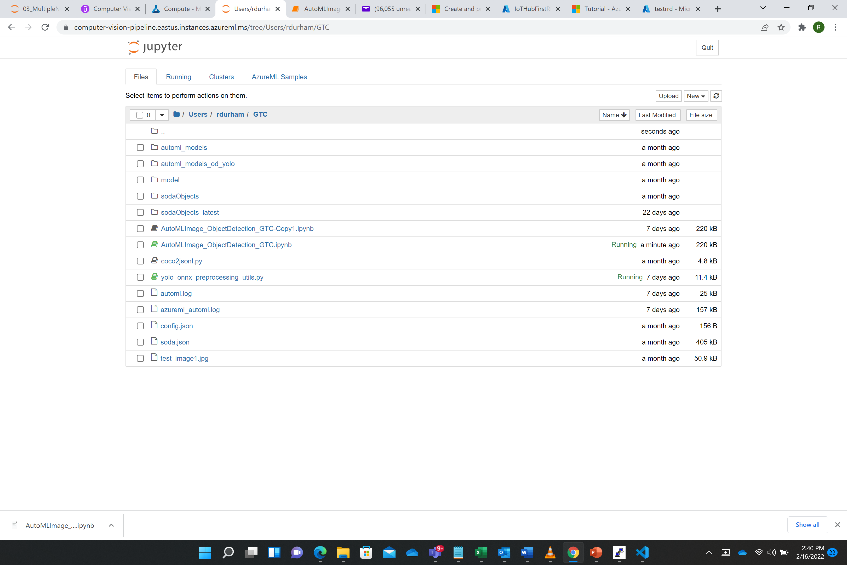



Upload the **yolo_onnx_preprocessing_utils.py** file into the same directory where the notebook is stored:

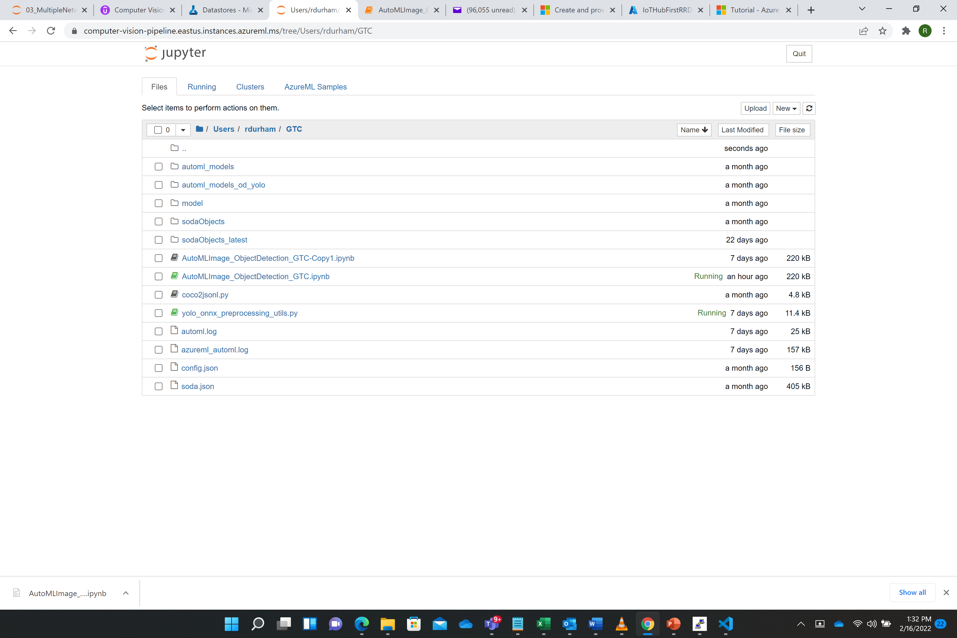



**Execute the AutoMLImage_ObjectDetection_GTC notebook:**

* 1. Click on the **auto-ml-image-object-detection_latest-V2.ipynb** notebook in the Juptyer environment. You will execute the following cells in order. In order to execute a cell click in the code cell and hold down on the shift key and press enter or execute the run command using the arrow: Example:
     1. 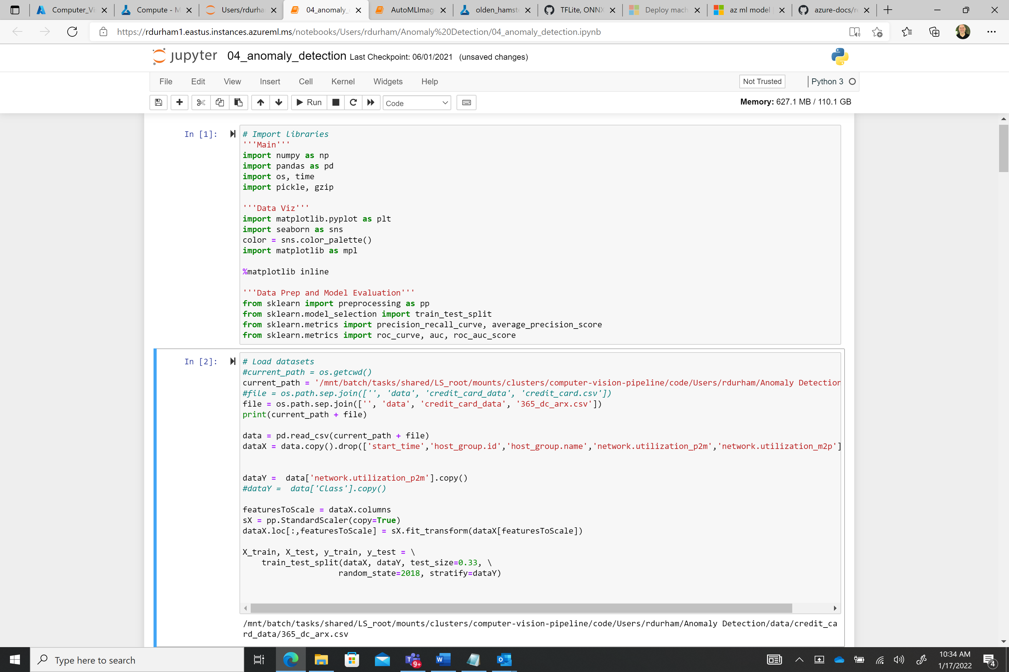



**Execute the following Jupyter Notebook cells in order:**

Please note that while we are executing this Jupyter notebook on a CPU (AML Compute Instance) that we setup when we configured the AML workspace, we will setup an additional compute target GPU (AML Compute Cluster) that will be used to train the computer vision model. We can upscale or downscale the GPU target to align with our workload that could be as few as a few hundred to several thousand images**.**

* + 1. Environment Setup
       - Please note after you execute the cell with the code “**pip install torchvision==0.9.1**” you need to restart the Kernel by going to the menu item Kernel and clicking on the "**Restart**" menu item. After this you can execute the next cell pip freeze which will show you all of the python libraries installed.
       - 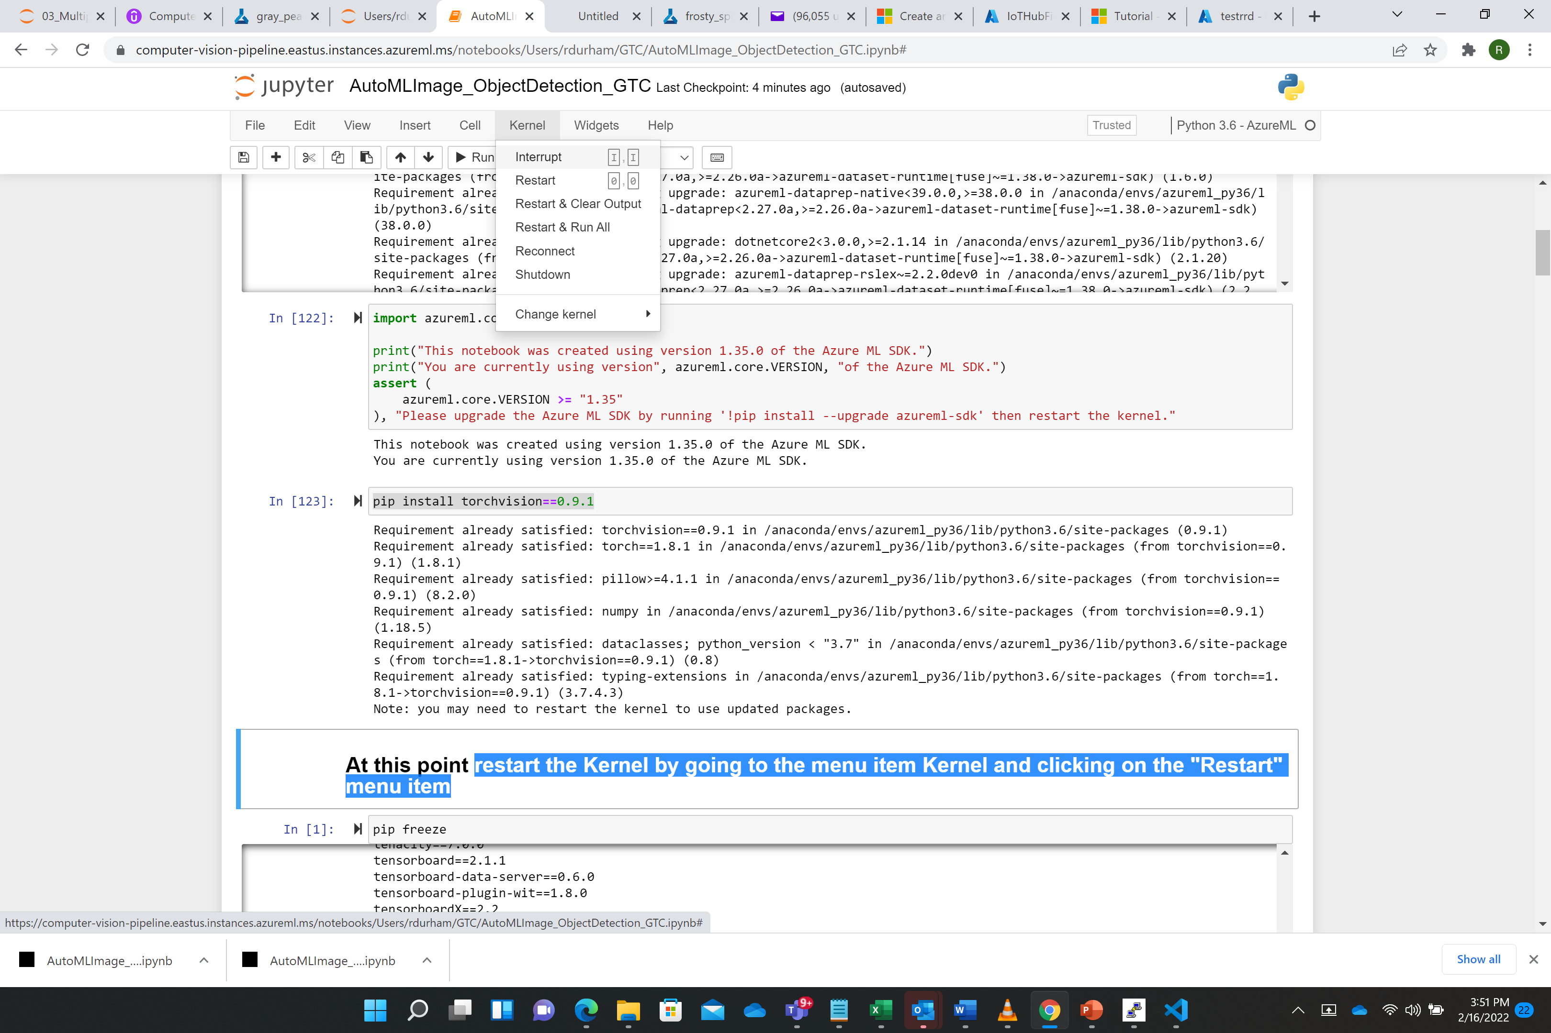



* + 1. Workspace Setup
    2. Compute Target Setup
    3. Experiment Setup
    4. Dataset with input Training Data (\*\*\***Please note you will need to replace the name in this step the AML dataset name you recorded earlier** in our example this was called **SodaDemo_20220126_144158** )
    5. View Training Set (you should see a dataset as shown below)
    6. 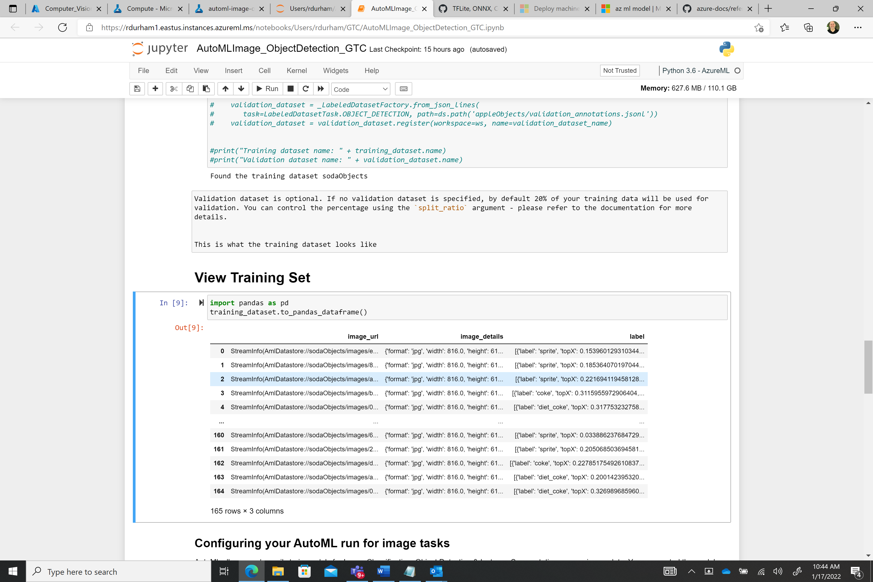

**Execute the following Jupyter Notebook cells in order:**

* + 1. Using default hyperparameter values for the specified algorithm
    2. **Submitting an AutoML run for Computer Image tasks**. This will start the AML training job and provide a link to the AML workspace to monitor the job. Additionally, execute the next cell which will stay in a holding state until the AML job finishes



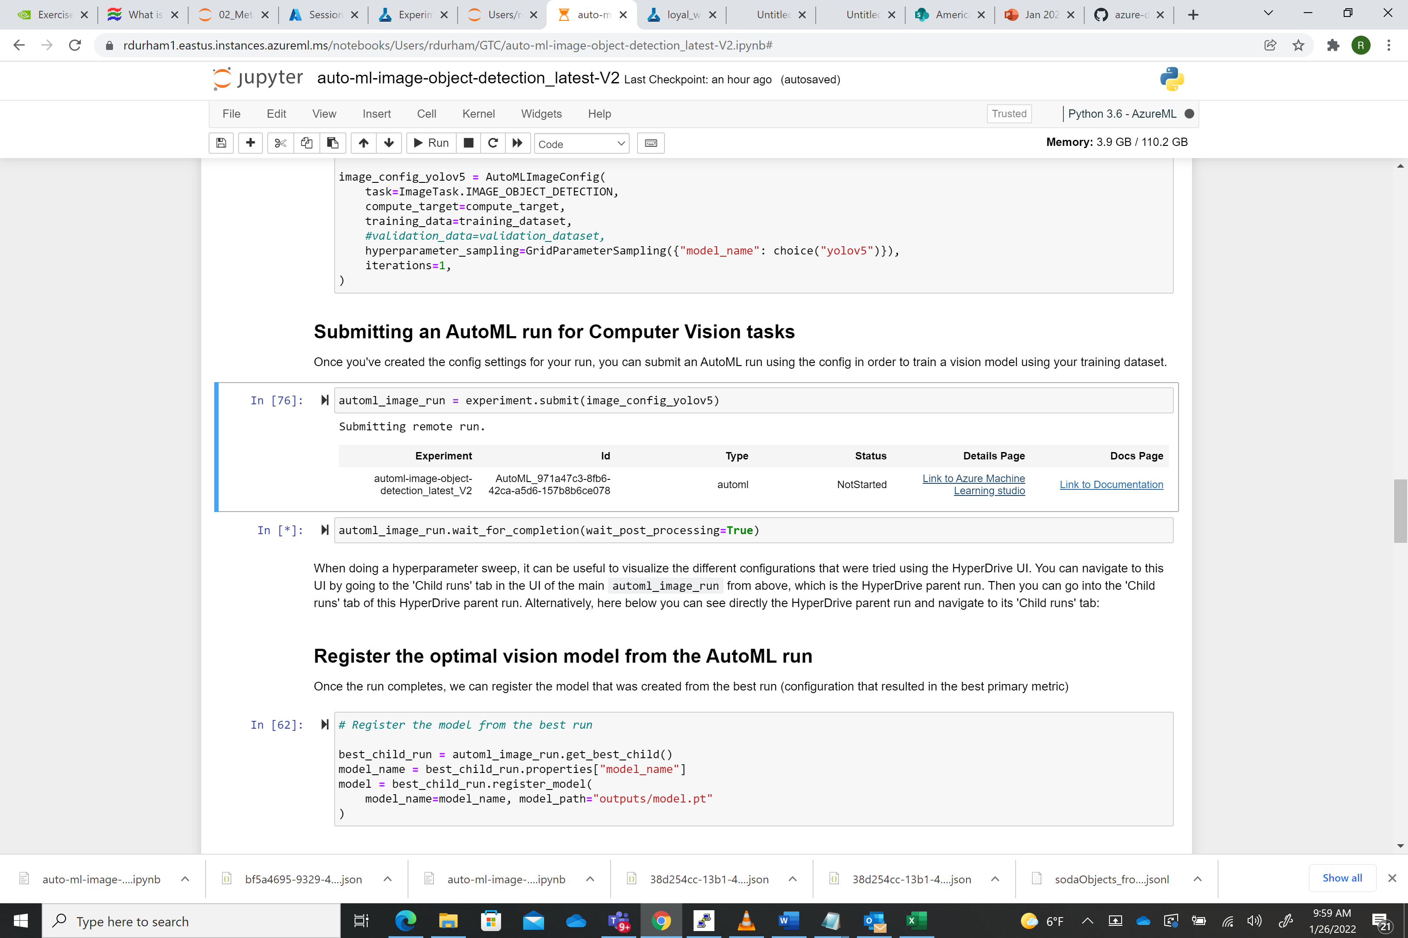



If you want to view the model training in AML click on the Details page shown below



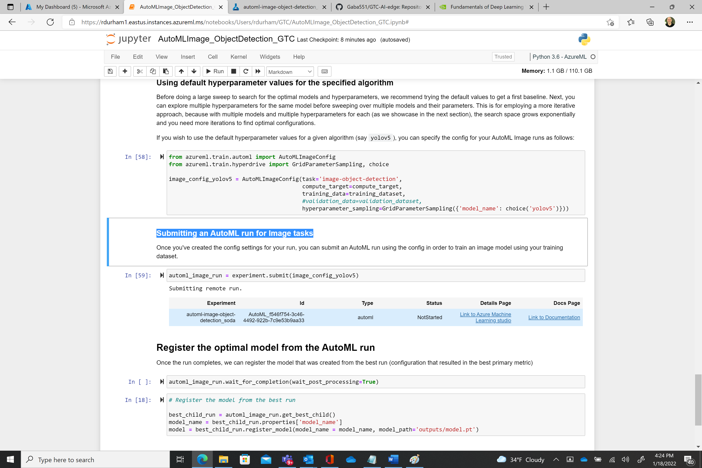



* + 1. It should be in a “**Running**” state. 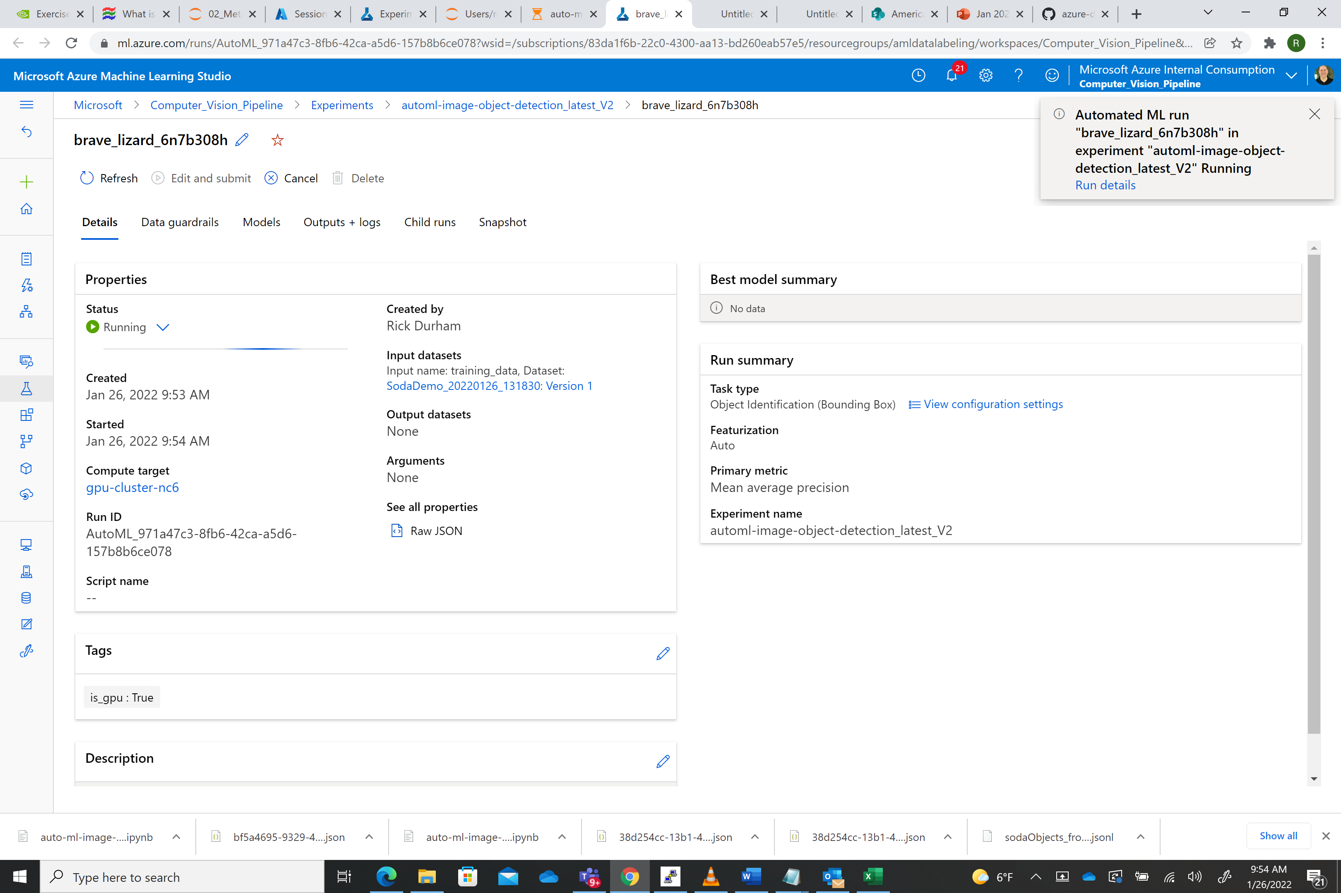



Once the model training job finishes executing you should see the following screen. By clicking on the **Algorithm name** in the **Best model summary** we can see the results of the model training:

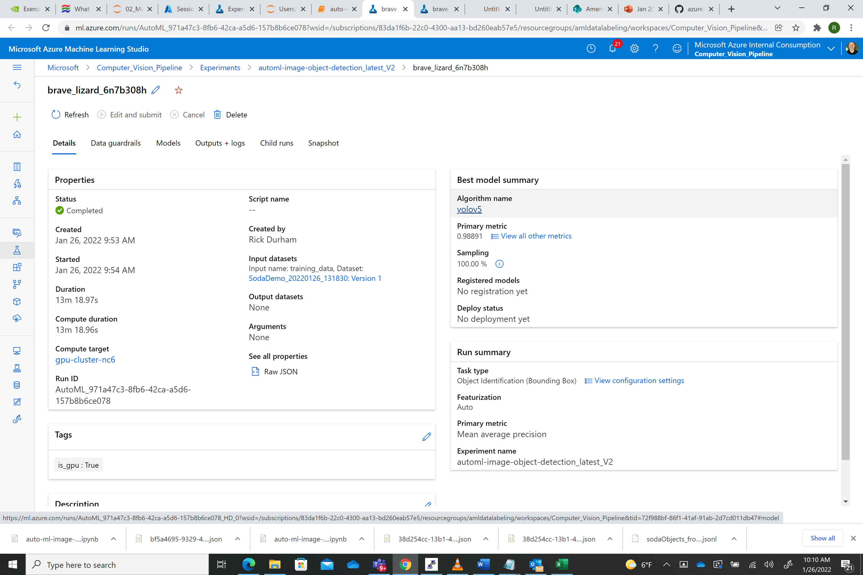



.

Clicking on **Outputs + Logs** and opening the training_artifacts folder will show you the model outputs in terms of the model and the label files:

Please note we see the *label file* (**labels.json**) the *yolo5 weights file* (**model.pt**) and the *ONNX model* (**model.onnx**) in this folder

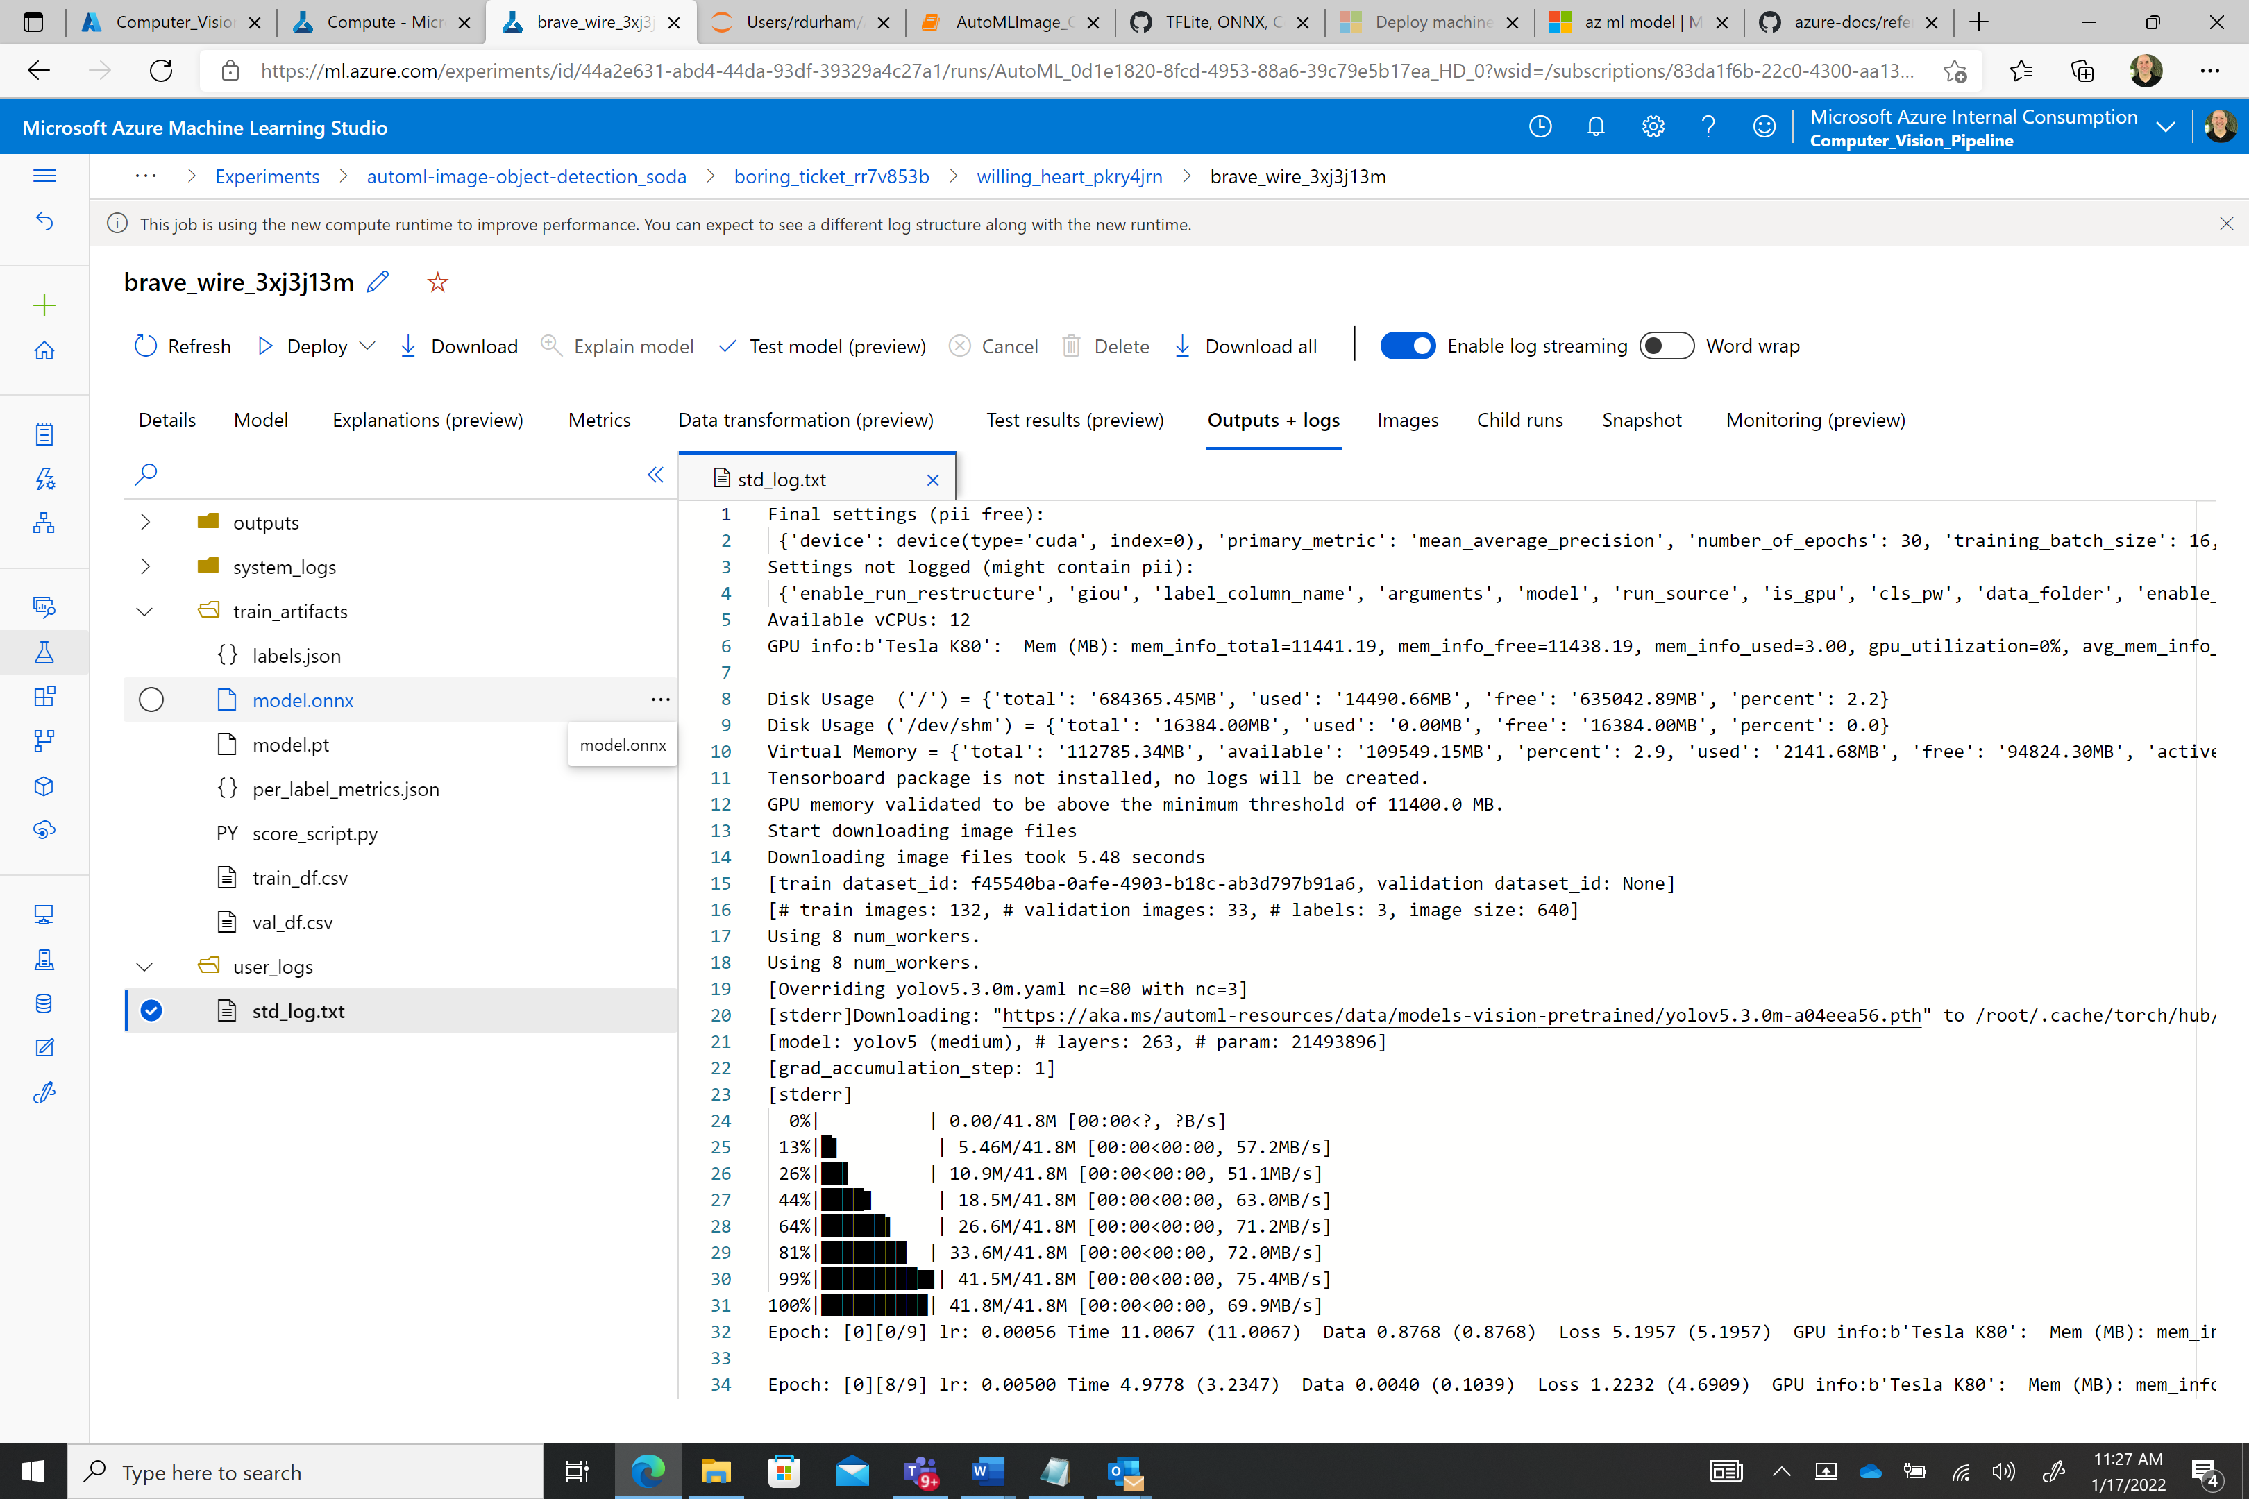



Switch back to the jupyter notebook

Once we have a trained model in AML we can register the model by executing the following cell in the Jupyter notebook:

**Register the optimal model from the AutoML run.**

Now that we have the model registered we are ready to download the ONNX model and the associated label file by executing the cell:

## Download the model and other associated files e.g. labels

## This step will create a directory in Jupyter called model and put the onnx model and label files in that directory:



If we click on the model folder we can see the following two files:



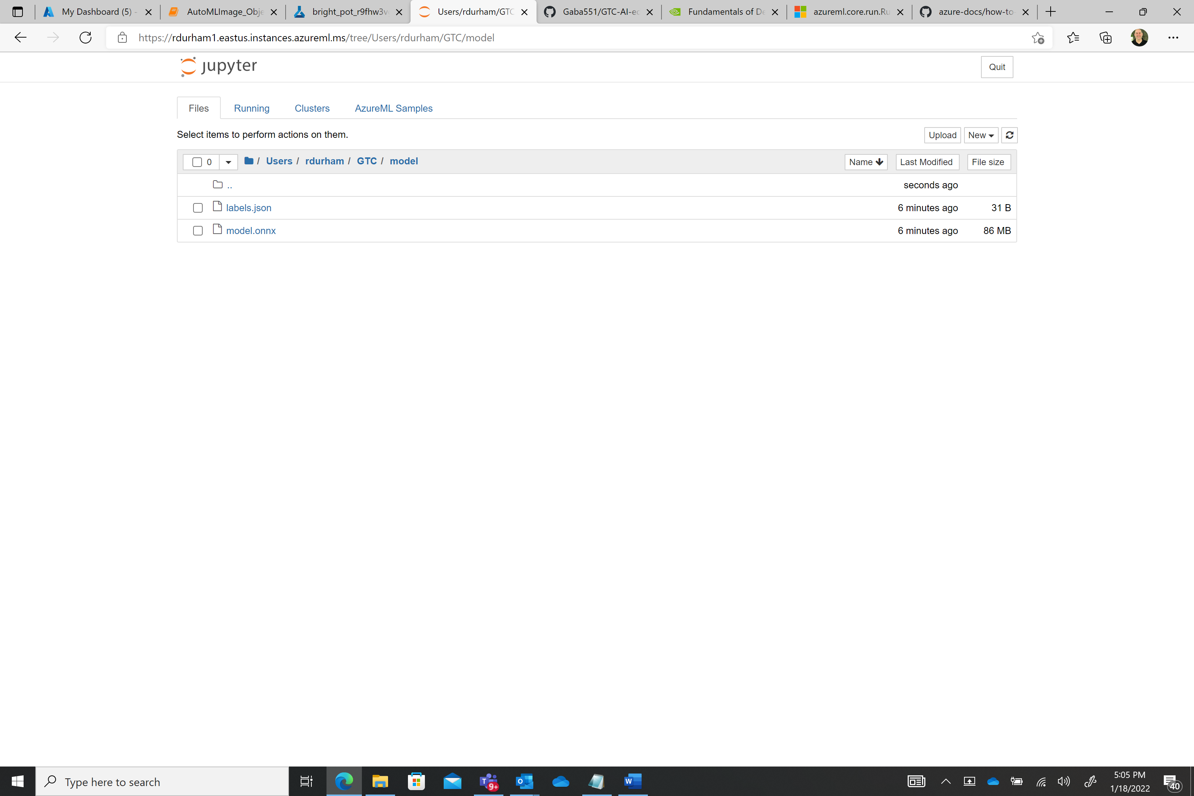

We can click on the text box and download each file to our local workstation.

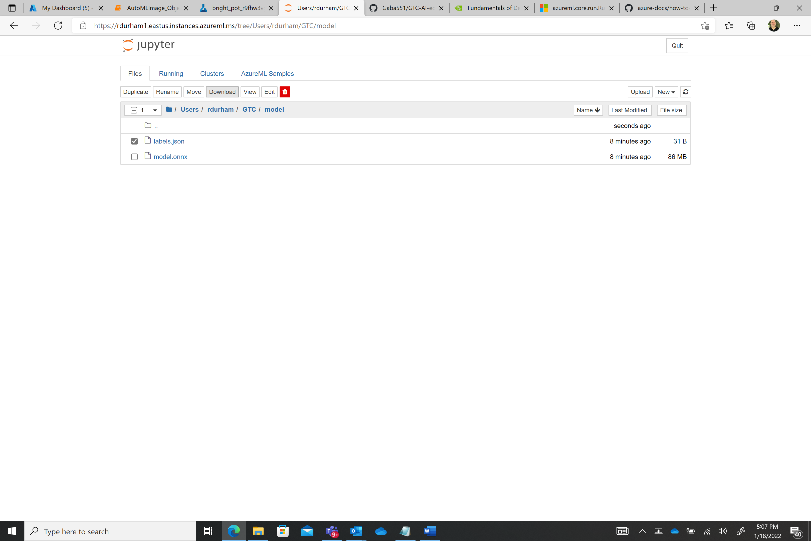



Now we have the label and model files needed to deploy to our device. We will use these later for our deployment to the target environment.



### If for some reason you need to retrieve your model and label files after your training run is over or you reopen the jupyter notebook later you can always execute the “**Optional: if you trained the model earlier you can still down load the model and label using Run id. This will be the highest level run id from a child run perspective**” cell. You will need to retrieve the **run_id** for the experiment to get the best model and labels file and replace the one in the sample notebook (see below).



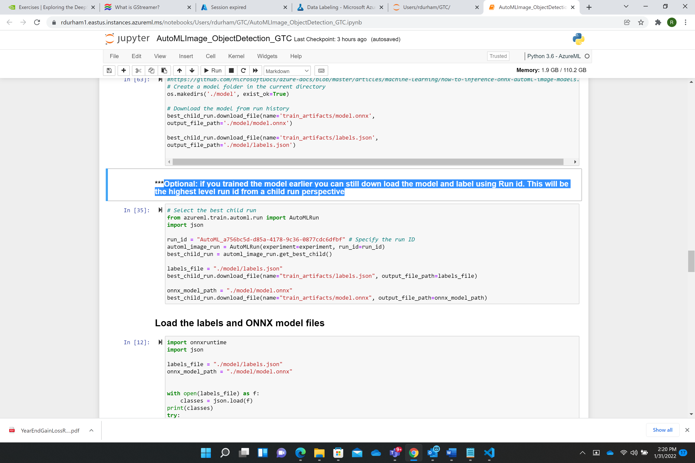



Now let’s take a look at how to use the model and the labels file to inference a test image:

Execute the **Load the labels and ONNX model files** cell. This will load the classes and session objects. Review the output results:

['coke', 'diet_coke', 'sprite']

ONNX model loaded...

Execute the **Get expected input and output details for an ONNX model** cell. This will output show the details of inputs and outputs of the onnx model.

No. of inputs : 1, No. of outputs : 4

0 Input name : input, Input shape : ['batch', 3, 640, 640], Input type : tensor(float)

0 Output name : output, Output shape : ['batch', 25200, 8], Output type : tensor(float)

1 Output name : 1397, Output shape : [1, 3, 80, 80, 8], Output type : tensor(float)

2 Output name : 1745, Output shape : [1, 3, 40, 40, 8], Output type : tensor(float)

3 Output name : 2093, Output shape : [1, 3, 20, 20, 8], Output type : tensor(float)

Execute the cells one-by-one following the **Image Inferencing Preprocessing** cell. These cells will perform the following



inferencing functions:

* Add helper functions and prediction functions
* Set the test image path that points to the test image
* Get predictions from the onnx model
* Invoke the **non_max_suppression** function to remove unwanted lower confidence bounding boxes
* Get the bounding boxes, labels and scores for each object in the image
* Plot the image with its respective objects, bounding boxes, labels and